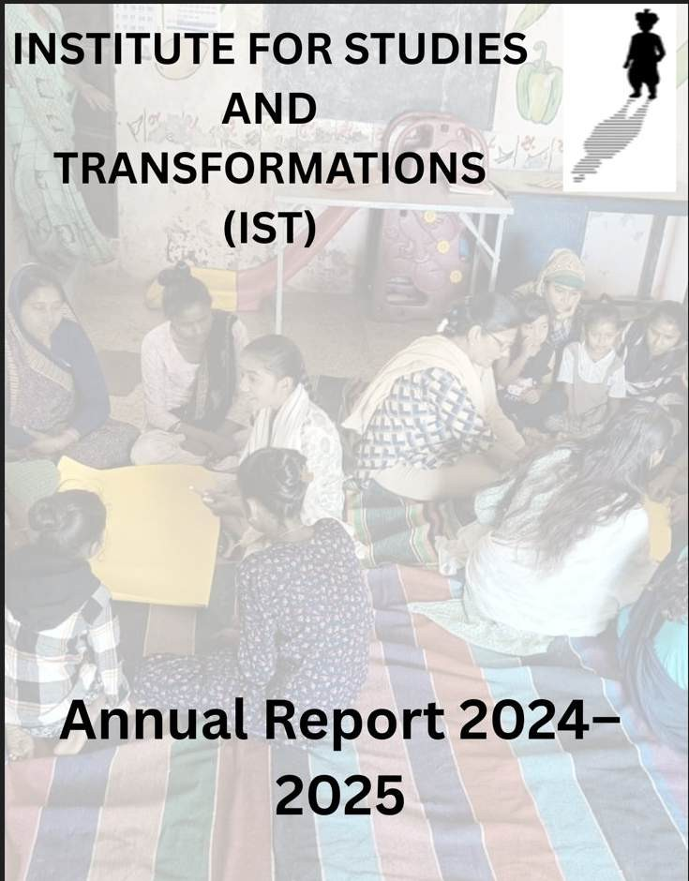

Foreword

Each year, we at the Institute for Studies and Transformations (IST) are reminded of the immense potential that lies in our communities—especially in their youth. The year 2024–25 was one of deep listening, deliberate action, and collective reimagining.

We traversed from village meetings under banyan trees to creative workshops in bustling bastis and national consultations on inclusive agriculture. In each space, young people stood up—not just to be heard, but to lead. Whether they were reclaiming civic spaces, reviving constitutional values in classrooms, or championing millet-based food systems, they were doing more than participating. They were transforming.

This year’s report captures the vibrant journeys of three flagship programs alined with the IST’s primary objectives:
- Pehchaan, which continued to grow a constellation of youth leaders.
- Udaan, which anchored children’s right to education with deep community collaboration.
- RRAN, which broadened our imagination of sustainable, equitable farming systems rooted in indigenous knowledge.

From immersive exhibitions and performances to workshops on critical thinking and community storytelling, Conflictorium became a bridge—between the personal and political, the individual and the collective, and the imagined and the real.

We are proud of the courage, conviction, and creativity that our teams and communities demonstrated throughout the year. We are grateful to our partners, donors, friends, and most importantly, the people who continue to walk with us—especially in uncertainty.

As we look ahead, we recommit to building spaces of transformation that are just, plural, and inclusive—where every young person is trusted with the tools to lead.

In solidarity,
Nayan Patel
Managing Trustee, Institute for Studies and Transformations April 2025

OBJECTIVE 1: TO SUPPORT THE DEVELOPMENT OF THE NEEDY, DEPRIVED AND DISADVANTAGED THEROUGH VARIOUS DEVELOPMENT INIRTIATIVES

A. Udaan education initiative:
The program envisions that, children from marginalized communities access quality, inclusive education in government schools rooted in democratic values of secularism and equality. This is supported by Edu-Leaders—trained community volunteers from disadvantaged, literate backgrounds—who promote RTE adherence, support SMCs, and advocate for education within their communities and with authorities. Udaan engages with two capacitated SMC members from marginalized backgrounds from each school who uphold RTE norms and school development plans. Additionally, voluntary educators in each block conduct daily one-hour support classes for Class 1–5 students using activity-based methods and toolkits to strengthen foundational learning and bridge gaps in government schooling.

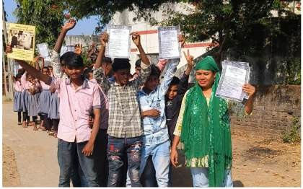
centric learning, and community engagement.
In the reporting period, Udaan continued its transformative journey across 7 districts of Gujarat—Ahmedabad, Anand, Aravalli, Chhota Udepur, Kutch, Panchmahal, Sabarkantha, and Modasa. The program remained committed to improving educational outcomes for marginalized children through grassroots leadership, participatory school governance, child-

Over the reporting period, Udaan's efforts focused on increasing school attendance, preventing dropouts, enhancing the role of School Management Committees (SMCs), and fostering civic awareness among students, parents, and local leaders.
The program made considerable strides in scale and outreach. With over 10,000 children engaged through various learning activities, school visits, and support centers, Udaan reached more than 5,000 community members through events, meetings, and advocacy efforts. More than 900 Edu-Leaders and SMC members were mobilized to work on school- related issues across over 100 schools. Around 30 support centers remained active in different districts, acting as local learning hubs that provided bridge education, emotional
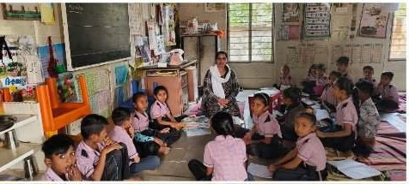
support, and a platform for children to explore arts, music, and values-based learning.

One of the core objectives of Udaan during this period was to ensure consistent attendance and prevent dropouts, especially among first-generation learners and migrant children. Through home visits, transport
arrangements, peer group mentoring, and community dialogue, many children who had

dropped out or were irregular in school began attending regularly. The support centers in Petlad, Ghoghamba, and Halol emerged as best-practice models, offering consistent academic and emotional support to children. Specific systemic issues, such as lack of classrooms or absentee teachers, were taken up by Edu-Leaders and SMCs through official channels, including block and district-level education offices.
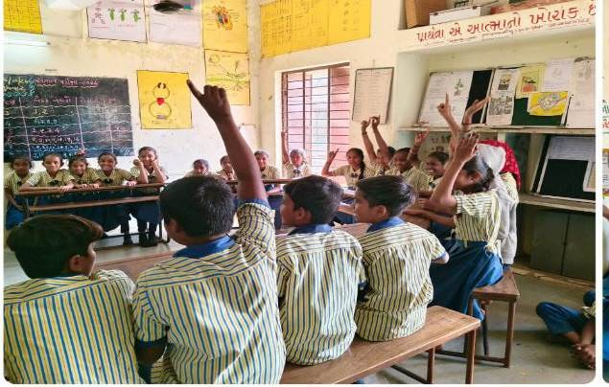
The year also saw an enhanced focus on building local leadership. Edu-Leaders and SMC members were trained on the Right to Education (RTE) Act, filing Right to Information (RTI) applications, and tracking the implementation of schemes like the National Means-Cum-Merit Scholarship (NMMS). In total, 42 RTIs were filed to address gaps in school infrastructure, teacher deployment, and learning
materials. Participatory planning exercises in Gram Sabhas helped community members secure classroom construction approvals and raise demands for teacher appointments. The consistent engagement with local governance mechanisms created a ripple effect, with schools receiving better monitoring and support from Cluster Resource Coordinators (CRCs) and Block Resource Coordinators (BRCs).
In line with Udaan's vision for child-centered education, the program organized a wide range of creative learning activities. Republic Day and Constitution Day events introduced children to constitutional values through songs, performances, and group discussions. Storytelling sessions, logical games, art activities, and newspaper reading sessions cultivated curiosity and critical thinking. Several support centers integrated harmonium classes, dramatizations, and value-based education, helping children build confidence and express themselves in safe spaces. These joyful learning models highlighted the importance of emotional and social development alongside academic progress.
In December 2024, an external evaluation of Udaan was conducted by Ms. Sunetra Deshpande with the guidance of Mr. Binoy Acharya. The evaluation focused on sustainability, scalability, and integration of innovation and learning of Udaan’s community- led School Governance model into government systems. Preliminary insights emphasized the replicability of the Udaan model, especially its community-based governance and participatory learning frameworks. In the coming year, these insights will guide Udaan’s next phase of planning and capacity-building, including anchoring community educators, developing digital learning tools, and expanding partnerships with Civil Society Organizations.

Stories from the Field
Addressing Drop-outs: A visit was conducted to discuss support for disabled individuals, widowed women, and to ensure quality education. During the visit, several key issues were addressed: Lakshmi Ben Raju Bhai Parmar, a girl who had dropped out due to financial constraints, was identified, and information about the Laxmi Yojana financial assistance

scheme was provided to help her re-enroll in school. Two children from private schools, Abarar Hussain (Grade 8) and Arfat Hussain (Grade 6), were unable to obtain their transfer certificates due to financial difficulties. The Taluka Education Officer (TPEO), along with local education leader Anwar Bhai Abdali, will facilitate their official enrollment. Additionally, two girls, Jiyabanu and Joyabanu Javedsha Diwan, who are eligible for the Guardian Assistance Scheme after their father’s death and their mother’s remarriage, are currently living with their uncle. Necessary documents were collected, and discussions were held with the Child Protection Unit to ensure they receive proper support. Follow-up actions will be taken to address these issues and provide the necessary support and education for the children.

OBJECTIVE 2: TO GUIDE TRAIN, TEACH, SENSITIZE INDIVIDUALS AND COMMUNITIES TOWARDS THEIR SOCIO-ECONOMIC DEVELOPMENT

Pehchaan Youth Program - Building active Young Citizen Leaders

Pehchaan Objective: Pehchaan aims to develop concerned and sensitive young citizen leaders who can work at two fundamental levels. First, they are encouraged to influence government departments to become more democratic, accountable, and transparent. Second, they are equipped to educate the community, create a new culture of engagement, and address issues of discrimination and conflict transformation. These leaders are trained in perspective-building, knowledge acquisition, and skill development. They are also supported in initiating leadership projects that ultimately strengthen civil society.

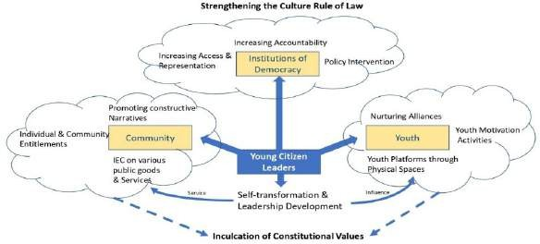
Why Pehchaan?
Our society today faces a complex web of interconnected challenges. In rural areas, the absence of youth-centric spaces restricts young people from engaging meaningfully in community life or
envisioning alternative futures. Simultaneously, there is a glaring lack of public discourse around constitutional values, scientific temper, and critical thinking—foundations essential for a healthy democracy.

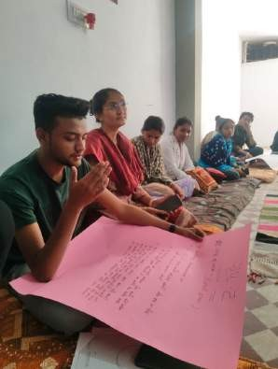

From long on ground experiences it has been observed that youth are increasingly being instrumentalized by polarized opinions, often leaving them disillusioned and divided Pehchaan as initiative brining youth at one platform from diverse background. At the same time, the most vulnerable populations continue to be marginalized, their voices and needs systematically overlooked. A significant gap exists in the representation of marginalized communities within local governance structures, further deepening the cycle of exclusion Pehchaan is designed to bridge this gap between the local democratic institution and communities at margins by developing capacity of youth as leader and pitching the voices of communities.

Urban areas, on the other hand, face the growing strain of distress migration, which puts immense pressure on already stretched public goods and services via program we tend to highlight the issues of migration among young population lying in village. Together, these systemic issues highlight the urgent need for an initiative like Pehchaan—a program designed to nurture youth leadership, foster inclusive dialogue, and build pathways toward equitable and holistic development with the roots lying in the village as unit.

Key Highlights: April 2024 – March 2025

Between April 2024 and March 2025, a wide range of impactful youth-led and community- based initiatives were carried out across several villages, demonstrating strong civic engagement, leadership development, and social change. Over 10 applications were submitted to local Panchayats by youth leaders addressing key infrastructure issues such as roads, drainage, water, and traffic regulation, leading to tangible improvements in village- level facilities. Transparency and citizen accountability were bolstered through the filing of more than seven RTI applications concerning roads, libraries, water, and land rights. A camp focused on updating Aadhaar, Ration, and Ayushman cards benefited over 50 villagers, while government scheme access work led to 6 RTE admissions, 2 gas connections, 5 new ration cards, 5 applications under the Kishori Yojana, and 14 sewing machine applications under the Manav Garima Yojana. Over 200 individuals received pensions, ration, or healthcare support during this period.

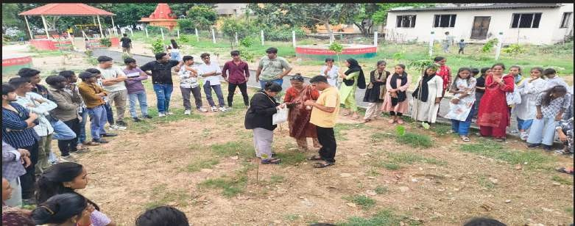

In the area of education, over 50 school dropouts were successfully re-enrolled and linked to scholarship programs. Additionally, five girls were admitted to ITI, two children were re- admitted via NIOS, and 20 orphans benefited from a minority scholarship survey conducted in Modasa. Employment-related activities included the submission of more than 60 recruitment forms for PSI and Constable roles, alongside awareness programs across six villages. Skill-building initiatives were linked through the Kaushalya Vardhan Kendra, offering computer and driving training. Health initiatives included a 10-day health camp in Navalpur, which served 78 people.

To further community awareness and safety, seven cyber fraud cases were identified and addressed, while youth groups also initiated video documentation projects about local history and national heroes. Six women’s groups were formed, and 10 training sessions were conducted to enhance their leadership and collective action. Youth also organized seven multicultural gatherings promoting unity and shared identity. Special events were organized for Eid Milan in Mangadh, peace advocacy during Ram Navami, and land allocation for a playground in Sureli. Civic awareness was deepened through six national observance sessions—two on Constitution Day and four on Women’s Day.

Leadership and capacity-building remained central, with one in-depth training on the Constitution conducted for team members and an exposure visit organized for adolescent
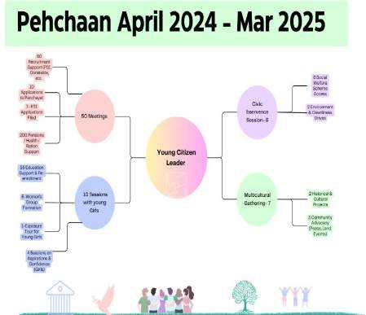
girls. Twenty-five monthly meetings facilitated program reflection and planning. Finally, sessions on aspirations and confidence were held for girls from September 2024 to January 2025, helping them articulate dreams and build self- belief. These diverse, grassroots- driven actions reflect a strong commitment to youth empowerment, social justice, and inclusive development across the region.

Case Stories of Change

- Youth-Led Initiative for a Playground in Sureli Village
In Sureli village, youth faced challenges in preparing for physical fitness exams due to the absence of a proper playground. Despite submitting a request five years ago, no action was

taken by the Panchayat. A group of local youth, including Aleem Bhai, formed a Youth Citizen Leaders (YCL) group under Pehchaan’s guidance. With more than 200 members, they engaged persistently with government officials, including the Panchayat and Taluka officers. Their efforts led to an official land survey and the approval of a playground under the MGNREGA scheme.

However, facing bureaucratic delays, the youth took matters into their own hands. They raised funds and cleaned the site themselves to make it usable immediately. Today, the playground serves as a hub for cricket, running practice, and community events. It has already helped over ten young people clear police fitness tests, with Sanvar Khan notably winning a 5 km race in just 19 minutes. Inspired by this success, neighboring Dhuletta village has launched a similar initiative. A cricket tournament is also being planned to support ongoing maintenance, demonstrating how youth can lead community transformation and build inter-community solidarity.

- Empowering Girls in Mangadh Village: A Story of Inclusion and Change Mangadh, a village in Idar Taluka, Sabarkantha District, has undergone a transformative journey through Pehchaan. The youth group here was spearheaded by 22-year-old YCL member Poonam from the Dalit community. Most girls in the village belong to Dalit and Muslim backgrounds, but early on, Muslim girls were notably absent from the group.

With guidance from Youth Facilitator Zareena Bain and support from a local Anganwadi worker, Poonam initiated conversations with the families of these girls. Many families were hesitant, fearing that participation in mixed-gender groups could lead to romantic entanglements. Through repeated dialogues and trust-building, families began allowing their daughters to engage in village-level activities.

Picture: Heritage walk at Ahmedabad girls from block Himatnagar and Thasra Participated

Looking Ahead: Stronger Together
To build on the current momentum, Pehchaan plans to:
  - Strengthen Youth Retention by offering structured mentorship and consistent engagement.
  - Enhance Women’s Leadership Participation by encouraging more female-led community initiatives and inclusive platforms.
  - Youth Resource Centres at the Block-level in 7 Blocks of 5 Districts.

OBJECTIVE 3: TO WORK TOWARDS THE CREATION OF A HUMAN ORDER IN SOCIETY FOUNDED ON UNIVERSAL LOVE FOR ALL CREATURE

A. Revitalizing Rainfed Areas Network (RRAN) – IST
In 2024–2025, the Revitalizing Rainfed Agriculture Network (RRAN) deepened its engagement across communication, capacity building, and community-led advocacy. The network focused on strengthening its internal and external communication strategies, revitalizing its brand identity, and expanding the millet ecosystem as a key intervention in nutrition-sensitive agriculture. Through collaborative consultations, workshops, creative storytelling, and inclusive outreach, RRAN significantly advanced its mission to make rainfed farming systems more resilient, visible, and people-centered.

I. Communication and Strategic Positioning: Strengthening the RRAN Identity
- Communication Capacity Assessment: To assess and enhance partner organizations' communication capabilities, RRAN initiated a Baseline Assessment across its network. Though initial participation was lower than expected, adaptive engagement strategies were introduced to build ownership. The assessment seeks to identify strengths, gaps, and opportunities for capacity development in strategic storytelling, media engagement, and advocacy. The findings will inform bespoke support structures that align with grassroots contexts and digital possibilities.
- Visual and Print Engagement Tools: Two creative communication tools are in development to drive continuous public engagement:
  - RRAN Calendar: A visually engaging calendar is being developed to demystify complex agricultural practices. Monthly infographics and case studies will spotlight indigenous farming innovations, making rainfed agriculture accessible to a wider audience.
  - RRAN Newsletter: Designed as a bridge between grassroots work and broader public and policy engagement, the newsletter will highlight research insights, network collaborations, and real-world impacts. It aims to simplify technical language for funders, civil society, and the media while creating interactive pathways for engagement.
- Key Learnings and Internal Alignment: This period underscored the importance of simplifying technical language without compromising content depth. Tools like the presentation and newsletter demonstrated the value of credible, consistent communication. Internally, RRAN’s communication strategy is increasingly aligned with global narratives and grounded realities. The capacity-building of core teams is beginning to yield more agile and strategic communication outputs.
- Learnings and Evolving Strategy: The strong demand for hands-on training and local institution building highlighted the need for long-term support systems around millets. Processing technologies, market access, and culinary adaptation remain crucial barriers. By shifting its emphasis from consultations to workshops, the network improved its ability to

respond to on-ground realities, enabling deeper community ownership and skill development.

B. Conflictorium – A participatory museum promoting peace and fraternity

Overview
In April 2024, Conflictorium proudly celebrated its eleventh anniversary in Ahmedabad and its second anniversary in Raipur. This significant milestone marks a journey of commitment to the arts, community engagement, and the exploration of pressing social issues through various exhibitions (5 over the two museums) and events (53 online and offline). Over the past year, we have hosted an array of impactful exhibitions that have not only enriched the cultural landscape but also fostered dialogues around identity, belonging, and social justice.
Raipur Exhibitions In Transit

In Transit opened at Conflictorium Raipur on April 14, 2024, examining the complexities of migration beyond a purely marginalised experience. The exhibition questioned ideas of choice, compulsion, and agency within migration. It explored citizenship and belonging, encouraging visitors to reflect on their own migration stories. Over the summer, audiences engaged in dialogues around individual–state relationships. The exhibition also highlighted the broader social and political implications of migration.
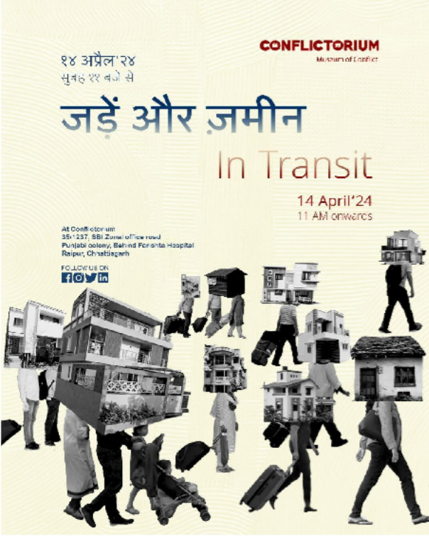

UnBlock: Bridging Individualistic Printmaking Techniques

UnBlock, an interdisciplinary exhibition curated by Sarika Goswami at Conflictorium, presented individualistic printmaking practices centered on environment and identity. It opened with an interactive performance by Vaibhav Yadav, engaging audiences through collaborative drawing and print-based exploration. Featuring artists such as Preeti Sahu and Ullas Bhaladhare, the exhibition fostered a dynamic dialogue between art, process, and personal narratives.
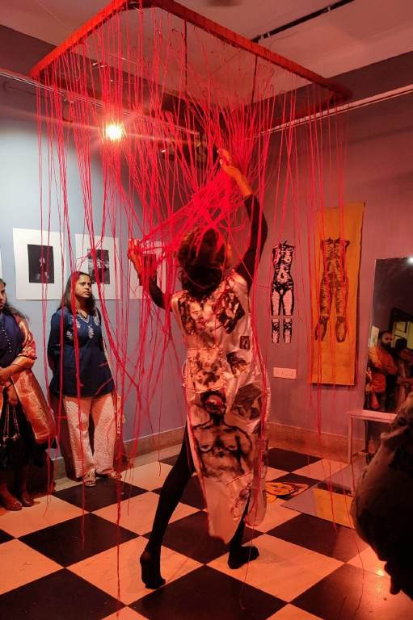

Ahmedabad Exhibitions Thresholds of Becoming
On May 12, 2024, Conflictorium Ahmedabad launched the exhibition “Thresholds of Becoming,” which invited visitors to consider their own thresholds of transformation. The exhibition facilitated moments of introspection, asking poignant questions about the choices individuals make and the internal shifts that accompany them. Participating artists, including Bedamati Majhi and Swati Kumari, presented works that encouraged viewers to reimagine their realities and challenge imposed frameworks of existence. This exhibition remained

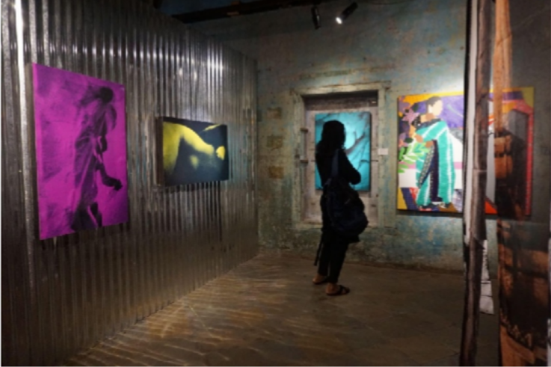
open for an additional week, allowing more visitors to engage with these transformative artworks.
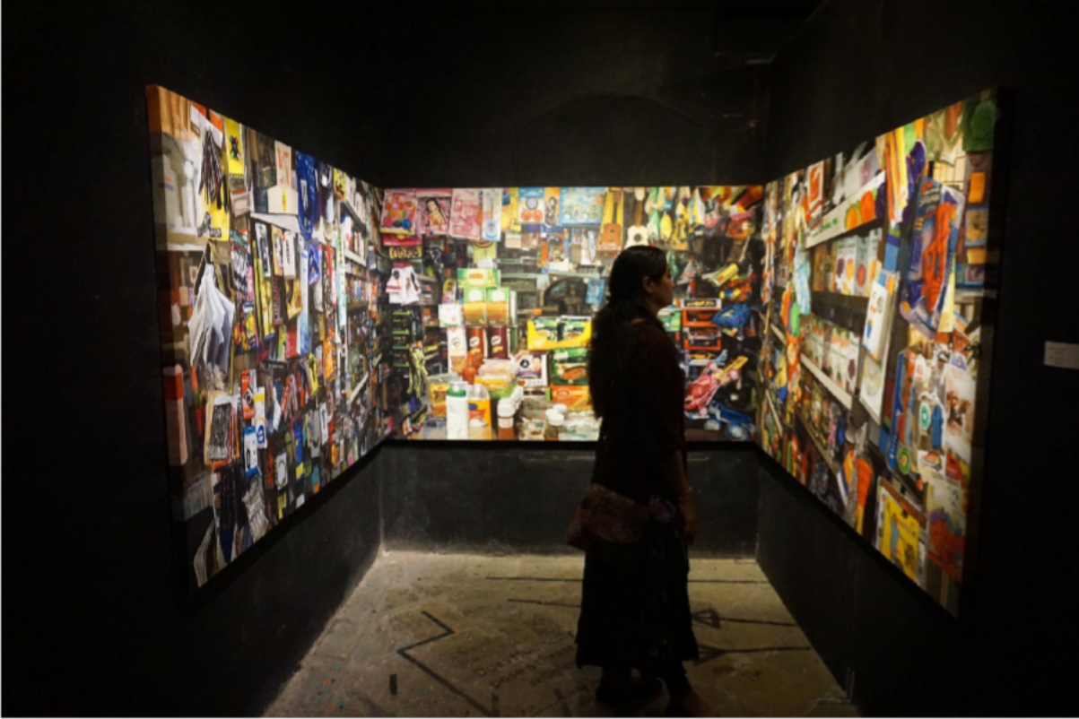

[Tender buttons, and another] Bellyache: A Contemporary Understanding of Womanhood
Another significant exhibition, titled “[Tender buttons, and another] Bellyache,” opened on July 5, 2024, and served as a continuation of the original exhibition. Curated by Shristi Sainani, this iteration aimed to explore contemporary understandings of womanhood through personal narratives, sociocultural encounters, and the often-overlooked histories of women in South Asia. The exhibition prompted discussions about societal expectations and the hidden struggles of women, culminating in the creation of “The Bellyache Mixtape,” a curated collection of songs and poetry that further explored the impact of patriarchy on women’s lives.

From Field to Frame: Grounding Collective Practices
On August 17, 2024, Conflictorium Ahmedabad hosted the exhibition “From Field to Frame: Grounding Collective Practices in the Outdoors,” organised by Raju Patel. This exhibition showcased the ‘Outdoor Practice’ group initiative and sought to shift the focus from market- driven art production to more exploratory interactions with nature. Participating artists, such as Aadil Khan and Anil Thambai, presented works that encouraged a re-evaluation of our relationship with the environment and our collective practices in artistic expression.
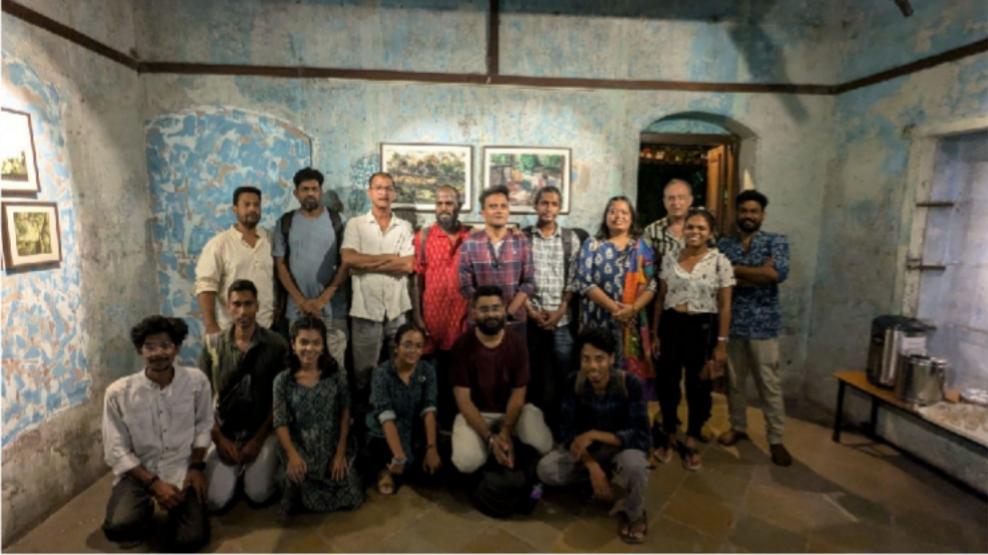

Artist Residency: Đinh Thảo Linh
As part of the ‘16 Breaths Per Minute’ residency programme, Conflictorium welcomed artist Đinh Thảo Linh, whose work explored the concept of maternity in art. Through her presentation titled “Maternity and Materiality in Art Practice,” Linh engaged the community in discussions about the nurturing qualities of materials and the spaces they inhabit. Her residency culminated in an open studio where she created a fictional hair salon, honouring Ahmedabad’s first certified hairdresser, Bachuben Nagarwala. Linh’s efforts to connect with the local community fostered a deeper understanding between the museum and its neighbours.
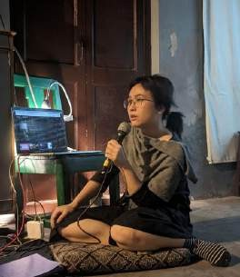

Events
Engaging Performances

Throughout 2024, Conflictorium Raipur presented performances engaging with identity, political suppression, and social realities. Run of the Mill by Avanish (August 4) offered an intimate reflection on vulnerability, hopelessness, and the search for love. On August 16–17, Firefly Women explored feminist utopias through the stories of three Indian women imprisoned under draconian laws, prompting dialogue on political repression and Indigenous women’s experiences.

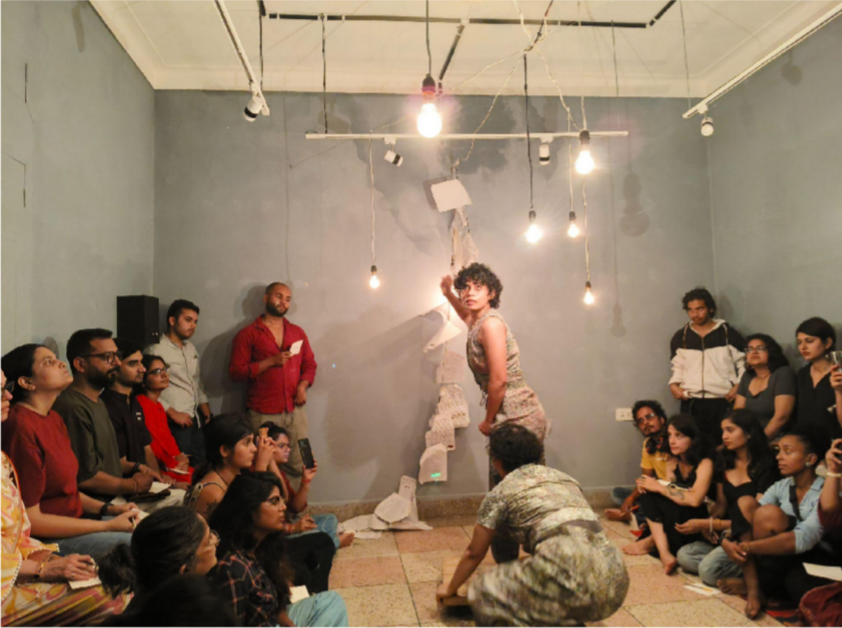
Community Engagement

On November 9, 2024, Conflictorium Raipur hosted Bastariha Pandum, a panel discussion on identity, tourism, and cultural preservation in Bastar, in collaboration with Agora Eco- Tourism. Community voices, including Mansingh Baghel and Sarita Vanjari, shared lived experiences highlighting pressures on local cultures. In November, Conflictorium also conducted Power Play, interactive sessions led by Roshni Sharma that used games to explore privilege, positionality, and power. Additionally, the All Things Living Environmental Film Festival (ALT EFF) screened environmental films, prompting discussions on climate change, tribal autonomy, and environmental justice.

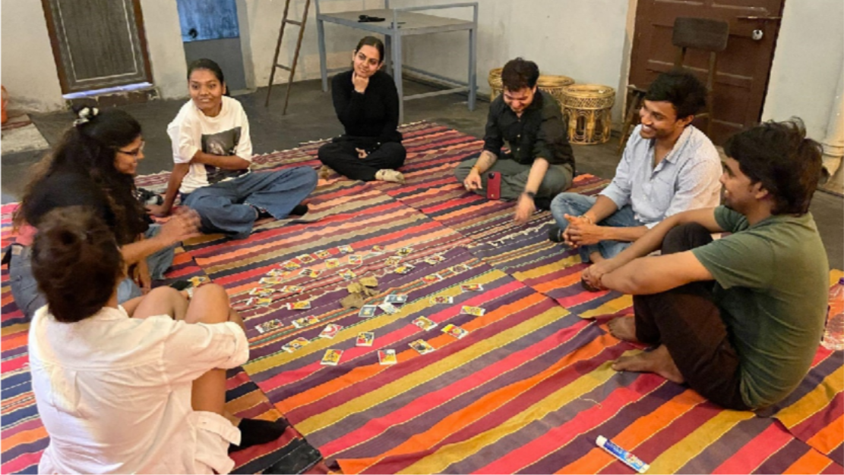

Fundraising Events: Community Support
Conflictorium Raipur also organised several fundraising events, including “Sangharsh ke Geet,” which featured the band Indian Roller. The concert not only provided a space for community members to come together in solidarity but also raised funds to support the museum’s operations. This successful event highlighted the importance of collaborative efforts in sustaining the museum’s mission to remain accessible to all.
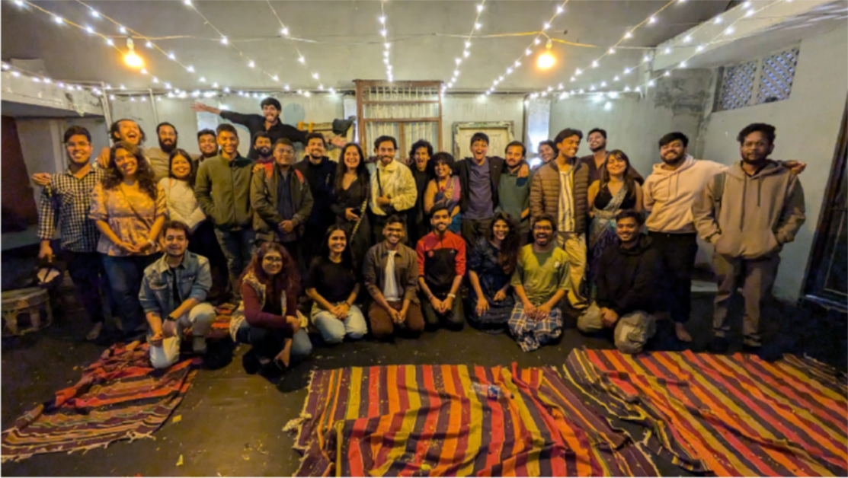
Outside the Museum

Over the past year, Conflictorium hosted a range of impactful programs exploring sound, democracy, and community engagement. Screenings of A Sound Democracy: Music, Movement & A Mob, including a session at SACAC for students, sparked critical discussions on the politics of sound, while the MatBhed board game enabled dialogue on religious freedom in India. The museum also engaged women from rural and tribal communities of

South Rajasthan, in collaboration with Jan Chetna Sansthan, through theatre-based creative workshops that culminated in a collective performance. Additionally, Conflictorium conducted customised workshops on Conflict Transformation and Critical Thinking for institutions such as IIT Gandhinagar, MGIS, and NGOs including Sanjeevta Foundation.

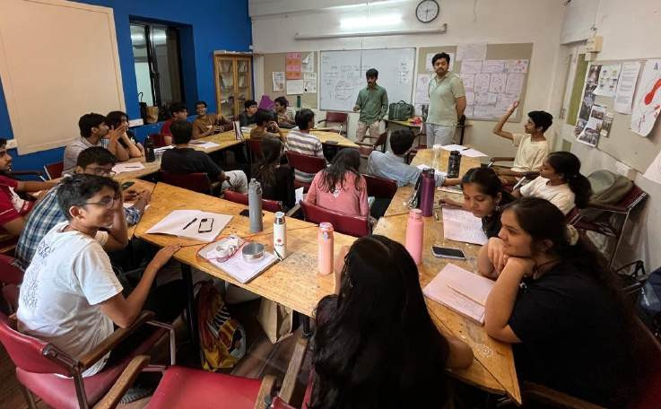

Engaging the Digital Space
In addition to physical events, Conflictorium has expanded its digital presence, facilitating workshops and discussions that engage audiences in meaningful dialogue. The online workshops, such as “Concern vs Currency” and “Disruption vs Disruption,” prompted participants to reflect on the conflicts inherent in societal structures and personal motivations. These virtual initiatives have fostered a sense of community, allowing individuals from diverse backgrounds to connect and share their experiences.


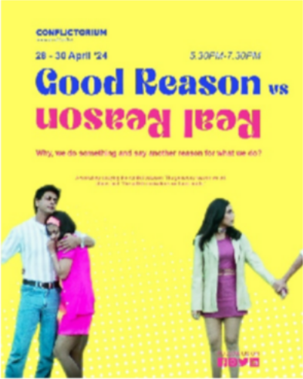
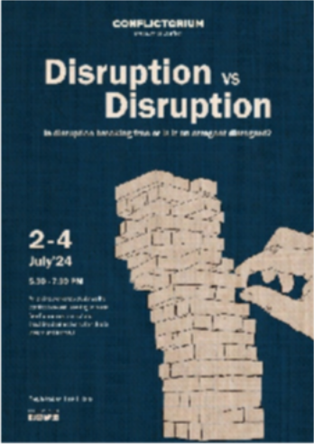

Conclusion: A Year of Reflection and Growth
The year 2024 has been a transformative period for Conflictorium, marked by a series of impactful exhibitions, performances, and community engagements. As we reflect on our accomplishments, we remain committed to fostering dialogues around identity, belonging, and social justice. We extend our gratitude to all stakeholders, community members, and artists who have contributed to our journey. Together, we look forward to continuing our mission of creating a space for reflection, expression, and connection in the coming years.

