ANNUAL REPORT 2023 -24

Institute for Studies and Transformations Ahmedabad (IST)

IST works with young people through its two initiatives, Conflictorium and Pehchaan, in Gujarat and Chhattisgarh. Pehchaan engages with young girls and boys belonging to disadvantaged communities in 12 blocks of 6 districts of Gujarat, focusing on strengthening their leadership and active citizenship by facilitating their learning and leadership journeys around social perspective, orientation of constitutional values & civic actions. Conflictorium is a participatory museum that focuses on arts and cultural practices on issues of conflict (self & societal) and engages mainly with youth from privileged backgrounds.
The Gujarat communal violence of 2002 led the Institute for Studies and Transformations (IST) to reflect, rethink, and strategize engagements with young people belonging to the marginalized communities who remained key actors during those times either as victims or as instrumentalized perpetrators. Since 2003, IST engaged approx. 7000 youth across three towns and villages across 15 blocks in 7 districts of Gujarat to work on resolving communal tensions within communities.
Currently, IST is engaged with approx. 183 young citizen leaders in Ahmedabad city and seven blocks of 4 districts. IST focuses on building leadership for self, community, society, and the planet through creative, dialogic, action-based methods. They facilitate community-level action for facilitating development/ social security entitlements. These Youth leaders, helped run the ration delivery, set up community kitchens, support migrant workers, and other COVID-19 relief work.
IST holds the Revitalizing Rainfed Agriculture Network (RRAN) secretariat through the Project Management Unit that supports the RRAN Advisory Committee. IST also runs the Neembadi Learning Center that caters to residential learning - many CSOs to benefit from the space - over 500 training workshops have been conducted so far in 6 years. IST also runs Conflictorium in Ahmedabad and Raipur to bring about social dialogue.
Economic and social inequalities are interlinked. The power structure is concentrated in the hands of the economically dominant and socially privileged. The vulnerable communities seldom get an equal voice within this—the vulnerable face constant discrimination in their day-to-day life. Among them, the women are the worst victims. Without any asset base and several social disadvantages, they are unable to sustain any economic activity and have to depend on others for means of livelihood. Consequently, they are exploited and live at subsistence levels without any savings, creating a negative cycle of deprivation. Hence, the importance of representing and safeguarding the rights of vulnerable identities through the local institutions of democracy is pivotal for human development.
Young people –those hailing from Dalit, Muslim and Adivasi communities, those from geographically remote areas and with lack of access and the ones with disabilities -are in even more vulnerable situation/s. They are often they are in conflict with their own community as well as with the ‘other’. In this context, adolescent girls and young women are the most disadvantaged with gender-based discrimination making their everyday life difficult.
Youth leaders from within the community can inspire and strengthen other young people and the community at large. These youth leaders can facilitate processes within the community to enhance resilience and democratisation of various platforms at their local institutions of governance and other fora.

OBJECTIVE 1: TO GUIDE TRAIN, TEACH, SENSITIZE INDIVIDUALS AND COMMUNITIES TOWARDS THEIR SOCIO-ECONOMIC DEVELOPMENT

A. Pehchaan Youth Program - Building active Young Citizen Leaders
The project initiative is aimed to engage and nurture about 200 young citizen leaders belonging to disadvantaged communities. Through this we will be able to directly engage with nearly 3,000 youth from these communities and districts and facilitate them in engaging constructively in Nation building processes by way of their own self-development, social perspective and in turn their leadership actions will benefit to the poor and needy people in their communities and regions.

- Capacitating youth to be aware of the matters of local governance & local institutions of democracy.
- Engaging Young Citizen Leaders (YCLs) to activate the participatory functioning of local Institutions of democracy and vulnerable communities through supporting the functioning of PHCs, Schools/ Anganwadis, and Village Panchayat Committees.
- Perspective building and constitutional value orientation to nurture value-based leadership among YCLs. -Building Camaraderie and positive relationships through diverse alliances through YCL and youth associated with them.

PROJECT OBJECTIVES
- Identification, capacity building, and handholding support for community leaders and facilitate them to setup and run community-based organizations.
- Identification and capacity building of community level para-legals.

- Capacitating and empowering young citizen leaders and providing hand holding support for their community-level initiatives.
- Supporting local CBOs to intervene and advocate for justice in cases of atrocities, mob lynching, and other incidents of violence.

Cause Sub-cause | and | Quantity | About beneficiary | the | Direct number | Impact | Indirect number applicable) | impact  (If | About the benefits provided
Education Support Classes |  | 12 | Children belonging to Dalit, DNT & Muslim communities |  | 264 |  | NA |  | Education coaching classes for these children have helped in preventing dropouts & improve their learning levels.
Facilitating entitlements & social security schemes by YCLs |  | 183 | Poor, Needy individuals & families belonging to underprivileged communities |  | 6254 |  | Awareness among communities about various  govt. schemes, their rights and due entitlements.
Health Check up camps by YCLs |  | 8 | Poor, Needy individuals & families belonging to underprivileged communities |  | 856 |  | Increased Health Awareness &  Reduction in Medical treatment cost |  | Health Checkups, Basic Medical treatment & Medicines provided to beneficiaries.
Physical youth spaces / information centres by |  | 4 | YCLs and associated them | youth with | 2600 |  | Access to  constructive physical space for youth in their |  | Information, guidance, career counselling, collective action by

YCLs |  |  |  | areas | youth have been facilitated through these spaces.
CBOs & Youth collectives setup & run by YCLs | 8 | Passionate YCLs and Community Leaders | 46 | Availability of community-based system to the vulnerable communities | Capacity building and other support provided to these CBO leaders.

Monthly Review, Monitoring and Reflection Meetings of Youth Facilitators:

In this reporting period, we conducted eight monthly meetings, comprising three two days sessions, three meetings of three-day sessions, and two one-day session. These meetings focused on:
  - Concise reviews of accomplished work,
  - Strategic planning,
  - Execution strategies,
  - MIS structure establishment,
  - Individual learning,
  - Experience sharing,
  - And, providing inputs.

Through these interactions, team members glean insights from each other’s experiences and contribute valuable input to address raised issues or concerns. Additionally, we implemented fortnightly local meetings at the district level, fostering quick response to emerging issues, experience sharing, and, mutual support.
Administrative matters such as monthly work reports, expense submissions, and MIS data were also addressed during these meetings.
Capacitating young citizen leaders and hand holding support to them in taking up community level initiatives:
We persist in our commitment to engage and provide support to the young citizen leaders who have been affiliated with us for past several years. These emerging leaders are now independently spearheading community-based initiatives, actively participating in districts and state-level endeavours led by various movements and organizations. They advocate for the rights, entitlements, and justice of marginalized communities, with some of them establishing organized groups, running centers, and conducting community-level activities.
Throughout this period, we facilitated and organized various programs and evens that involved these dynamic young citizen leaders.
Following programmes/events were organized during this period involving the young citizen leaders.
Sr.  No. | Event Programme | Place | No of people  Participated
1 | Ambedkar Jayanti was jointly organized by Dalits and Muslim youths at Manjipura. | Manjipura | 35
2 | Pre-Monsoon work was initiated, including the cleaning of drainage systems in Aklachan and Dhunadhara to prevent water logging | Aklachan and Dhunadhara | 10
3 | A Shared heritage walk took place with Hindu and Muslim youths in Ahmedabad on 18th  October 2023. | Ahmedabad | 15
5 | An evening of poetry was organized under | Ahmedabad | 32

 | the aegis of ‘WeThe Kalakaar’, at Art’o Terrace, Ahmedabad on June 11, 2023
6 | Career guidance program were organized at Thasra and Himmatnagar. | Thasra and Himmatnagar | 52
7 | Another poetry evening, organized by ‘WeTheKalakaar’, took place at Conflictorium in Ahmedabad on July 8th,  2023 | Ahmedabad | 25
8 | A medical checkup camp and distribution of free medicines were conducted. | Umreth &  Ghoghambha villages | 350
9 | A blood Donation camp with the message of  unity was organized. | Himmatnagar &  Panchmahal | 230
11 | A cultural program, ‘Yuva vichar’ was  organized. | Himmatnagar | 31
12 | Two awareness meetings on education issues were held in Ghoghambha with YCLs. | Ghoghambha | 42
13 | A one-day camp for 'E Nirman,' Aadhar Card, E-shram, and Ayushman was organized. | Mangadh, Himmatnagar, Vadinathpura and  Ghoghambha. | 489
14 | A cricket tournament for peace and friendship  building among Dalit and Muslim communities was organized. | Lalpur, Himmatnagar | 40
15 | Dalit, Muslim and Christian youth jointly submitted applications for their basic amenities in their areas at sundalpur. | Sundalpur | 12
16 | Borewell was completed in Thasra. | Thasra | 08
17 | Six youths secured jobs through bharati mela facilitated by YCLs. | Himmatnagar | 06
18 | A Mehndi competition with Dalit and Muslim girls were organized at Modasa. | Modasa | 22
19 | A women’s awareness program with men was conducted in Modasa. | Modasa | 35
20 | A grant of 1.25 lakhs was approved for developing basic facilities at the graveyard at Manjipura. | Manjipura | 10
21 | Distributed a booklet titled 'Aamukh,' which translates to preamble, containing an insightful exploration of each word in the preamble of the Indian Constitution. This initiative aimed to enhance awareness and understanding of the foundational principles that shape the Indian constitutional framework. | Ahmedabad, Himmatnagar, Panchamahal, Modasa, Idar, Pratinj, Anand, and Kheda | 450 copies

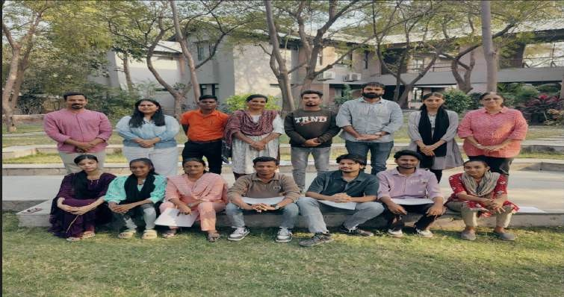
The Buniyaad team has identified 183 emerging young citizen leaders whom they will engage and collaborate with over the next few years.

District wise no. of identified YCLs
District / Block | No. of YCL (Male) | No. of YCL (Female) | Total No. of YCL
Panchmahal | 81 | 25 | 106
Sabarkantha | 24 | 17 | 41
Anand & Kheda | 25 | 11 | 36
Total | 130 | 31 | 183

During the reporting period, we successfully conducted two more capacity-building programs aimed at enhancing leadership skills and fostering the sharing of insights gained from their respective initiatives. Our focus extended to fortifying participants’ social perspectives on issue such as caste, gender, communalism, and engaging in discussions on pertinent current affairs in the state and the country. These discussions encompassed their understanding on communal violence, caste issues, and rights of human, increasing threat to constitution, election processes and its impacts on lives of the marginalized communities.
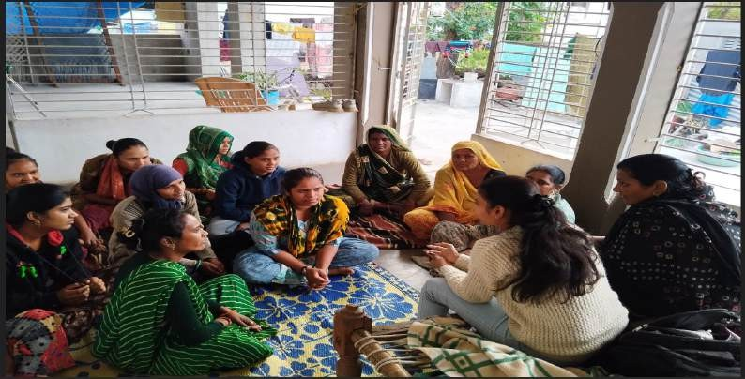

Notably, we initiated a dedicated workshop for young girls, a strategic move to bolster female participation in our various initiatives where we identified a gap. A total of 60 young girls actively participated in this workshop. The overarching objective was to ensure inclusivity and increased representation of girls and women in our programs.
Furthermore, we facilitated the development of a plan and concrete actions by youth to strengthen a culture of diversity. This involved promoting diverse practices in the everyday lives of youth within the communities they engage with. Each Young Citizen Leader (YCL) was facilitated to design and develop their individual youth action plan. Additionally, collective block-level activity plans were formulated to engage numerous youth in various conflict transformation events and process.

Sr.  No. | Date | Programme Details | Place | No. of YCL  participants
1 | 7th to 9th July 2023 | Leadership building &  designing individual youth actions | Neembaadi, Sanand | 48
2 | 22nd to 24th September 2023 | Leadership building & designing individual youth actions with young  girls | Neembaadi, Sanand | 60

Youth Empowerment: A transformative three-day camp in Udaipur
Additionally, a three –day Youth Camp was organized from September 7th to 10th, 2023, in Udaipur. A total of 78 participants from Ahmedabad, Panchmahal, Anand, Kheda, Modasa, Himmatnagar, Idar and Prating actively participated in the camp. The primary objective of the camp was to enhance youth activities, strategize the creation of new youth spaces, provide insights into the current social scenario, and encourage creative planning for engaging more youths to develop their leadership skills.

Throughout the camp participants gained an understanding of how their needs and human rights are interconnected. They explore the correlation between fundamental rights and duties, delved into existing youth spaces where significant interaction and learning occur, and engaged in various games to comprehend the role of collective leadership.

Discussion during the camp included an examination of youth policies and the identified needs of the youth. The culmination of the camp involved taluka-wise and individual planning of activities, as well as the development of different youth spaces. Creative ideas emerged including:

- The proposal to create a youth-run YouTube channel dedicated to promoting peace and harmony.
- Youth-led spaces for various activities.
- Setting up libraries in different locations.
- Mobilizing funds through community piggy banks to support different activities.
- Initiating different sports activities.
- Film screening on different subjects.
- Learning of different languages.
- Meeting once in three months.

The camp facilitated the generation of innovative strategies and plans to empower and mobilize the youth for positive social impact.

Successful achievements of YCL’s community actions:

Each YCL has undertaken individual actions addressing a variety of issues, encompassing problems faced by individuals, families, and several civic concerns. Through their community-level youth initiatives, YCLs have successfully reached out to 11,887 individuals and families encountering difficulties in accessing their rights and entitlements. Remarkably, they have facilitated 6,253 individuals and families in obtaining their rightful rights and entitlements.

Sr.  No. | Name of  scheme/entitleme nts/Information | No. of  Persons / families provided information | No of  persons/familie s supported in submitting evidences | No of  persons/famili es supported in filing  forms/drafting  applications | No of  persons/fami lies accessed right/benefit | Amount of Benefits
1 | Aadhar Card | 1518 | 927 | 927 | 823 | -
2 | Election Card | 620 | 530 | 530 | 219 | -
3 | E-Shram Card | 3900 | 2173 | 2173 | 2173 | -
4 | Income certificate | 152 | 152 | 152 | 152 | -
5 | Caste Certificate | 55 | 50 | 50 | 49 | -
6 | Death Certificate | 12 | 12 | 12 | 12 | -
7 | Marriage  Certificate | 38 | 38 | 38 | 38 | -
8 | Birth Certificate | 50 | 30 | 30 | 24
9 | Kunvar Bai nu Mameru | 93 | 93 | 93 | 93 | 10  thousand to each
10 | Sukanya Scheme | 01 | 01 | 01 | 01 | -
11 | Old age pension | 28 | 25 | 25 | 22 | -
12 | Widow pension | 130 | 110 | 110 | 100 | -
13 | New Ration Card | 500 | 245 | 245 | 222 | -
14 | Toilets | 06 | 06 | 06 | 06 | -
15 | Ration Kit to needy and affected  families | 46 | 46 | 46 | 46 | -
16 | Manav Garima Yojna | 50 | 40 | 40 | 40
17 | Vahli Dikri Yojna | 10 | 09 | 09 | 08
18 | Palak Mata Pita Scheme | 10 | 10 | 10 | 10
19 | Ujjawala Scheme | 50 | 20 | 20 | 11 | -
20 | PM Kishan Scheme | 200 | 105 | 105 | 105 | 2  thousand per person
21 | Ayushyman Card | 2000 | 1500 | 1500 | 668 | -
22 | Scholarships | 500 | 300 | 300 | 279
23 | Shramyogi card | 20 | 18 | 18 | 18

24 | Housing Scheme | 50 | 15 | 15 | 10
25 | Food Protection Scheme | 50 | 40 | 40 | 38
26 | Construction of new roads | 08 | 08 | 08 | 08
27 | Construction of new sewer | 04 | 04 | 04 | 04
28 | Street lights | 15 | 12 | 12 | 12 | -
29 | Bus service application | 03 | 03 | 03 | 03
30 | Drinking water connection | 06 | 06 | 06 | 06
31 | Aanganwadi application | 01 | 01 | 01 | 01
32 | Pan card | 520 | 380 | 380 | 320
33 | Driving licence | 200 | 100 | 100 | 87
34 | PWD travel pass | 100 | 100 | 100 | 100
35 | E-Nirman Card | 58 | 58 | 58 | 58
36 | MNREGA Job  card | 50 | 30 | 30 | 21
37 | Passport application | 34 | 34 | 34 | 34
38 | Domicile certificate | 05 | 05 | 05 | 05
39 | Non-Creamy layer certificate | 11 | 11 | 11 | 11
40 | Manav Kalyan Scheme | 200 | 80 | 80 | 58
41 | Abha Card | 400 | 200 | 200 | 176
42 | Bank account opening | 90 | 90 | 90 | 90
43 | RTI application | 12 | 12 | 12 | 12
44 | Farmer compensation | 08 | 08 | 08 | 08
45 | Farmer loan application | 20 | 20 | 20 | 20
46 | Ration Card in  NFSA scheme | 20 | 10 | 10 | 06
47 | Loan application for studies abroad | 05 | 03 | 03 | 02
48 | Support for buying pushcart | 03 | 03 | 03 | 03
49 | Stitching Machine | 10 | 05 | 05 | 03
50 | Cataract operation support | 05 | 05 | 05 | 05
TOTAL |  | 11877 | 7683 | 7683 | 6253

Block wise segregation of data

Block name | No. of entitlements
Ahmedabad | 926
Ghoghamba | 753

Halol | 11
Himatnagar | 1586
Idar | 799
Jambughoda | 03
Modasa | 912
Umreth | 1263
Grand Total | 6253

The Young Citizen Leaders of Himmatnagar observed that many young girls in marginalized communities, particularly in Dalit and Muslim populations, were facing restrictions on pursuing higher education. In response, the YCL organized awareness programs aimed at promoting education for young girls and boys.
During these initiatives, the YCL come up with alternative idea along with spreading awareness on education. The idea was to initiate demand for distance learning center of DR. B.R. Ambedkar Open University. Recognizing the potential of such a center to address educational barriers, the YCL demanded for the establishment of Dr. B.R. Ambedkar Open University Center. This strategic move aimed not only to support girls facing restrictions on higher education but also to foster unity among Dalit and Muslim youth.
The Joint effort to advocate for the opening of the center has commenced, with ongoing follow-up with the university in Ahmedabad. Despite the ongoing process, this initiative has already strengthened the sense of unity among Dalit and Muslim youths, who collaboratively emphasize Dr. B.R. Ambedkar as a symbol of education across society.
Bridging Divides and Fostering Unity on Eid-e-Miladun-Nabi in Modasa on 28th September 2023, The YCL in Modasa orchestrated a thoughtful initiative on the occasion of Eid-E-Miladun-Nabi. The plan entailed the distribution of flowers to individuals, accompanied by a resonant message of love and harmony, strategically designed to counteract divisive political narratives. The primary objective was to propagate a message of unity and foster communal harmony within the community.
This commendable initiative garnered widespread appreciation from diverse communities. Throughout the entirely of September 28, 2023, the YCL diligently distributed flowers, symbolizing the essence of togetherness and inclusivity. The strategic timing of the initiative on Eid-e-Miladun-Nabi underscored the commitment of the YCL to promoting a culture of understanding and goodwill within Modasa.

We the Yuva’ Annual Youth Conclave: Celebrating Diversity, Fostering Scientific Temper, and Crafting a Manifesto for Change": The ‘We the Yuva’ Annual Youth Conclave held at Neembadi drew 230 participant from Anand, Ahmedabad, Kheda, Panchmahal, Sabarkanha, and Aravalli, representing diverse backgrounds including Dalits, Muslims, Adivasis, and OBC youths. The conclave, centered around cultural programs, aimed to celebrate diversity and engage youth creatively.

Various spaces were designated to encourage artistic expression, including drawing, selfie points, and writing messages for social causes, fostering interaction among participants. The selfie points carried powerful messages such as “We the Yuva”, “For Liberty, Equality, Fraternity,” “Let’s give wings to our dreams,” “Let’s spark the fly,” and “Uman Hai Udaan Ki,” which resonated well with the youth who actively participated by creating beautiful drawings and messages.

The conclave began with a panel discussion on developing scientific temper, featuring Mitali Samova, Kiran Trivedi, and Nayan Patel, moderated by Hozefa Ujjaini. The panelists highlighter how scientific temper can influence attitudes and behaviors, fostering reflectin, questioning, challenging, changing, developing critical thinking and building new knowledge in society. This is need for the development of the society at large.

The cultural program that followed showcased diverse performances from Muslim, DNT, Dalit and Adivasi communities. Acts included a welcoming folk dance by Adivasi girls, Tabla performance by a Muslim youth representing different styles from various state, encouraging songs by the chhara band from DNT communities, Sufi music by a Muslim DNT meer community performer, mimicry imitating voices of birds and animals by a young boy, and a filmy dance by another talented youth. Aatish and Sunny Patni rectited poetry of protest, and the youth enthusiastically celebrated this diversity through this various art forms.
The event also felicitated youths from the working areas that achieved success or participated in sports at inter-college or state level to encourage sportsmanship and sports activity among youth. And through sports how we can come together.
In addition to the cultural program, the youth collectively formulated a “Manifesto of Change”, advocating for societal transformation, peace, and the rejection of violence. This manifesto, symbolizing their commitment to securing a peaceful future, was signed by all participants.
The full day conclave’s design, encompassing input sessions, sports encouragement, entertainment, and artistic expression, aimed to foster acceptance, respect and celebration of diversity. The whole program was anchored by Khairunnisha Pathan and Waahid Rajpura through their innovative styles.

Identification, Capacity building and handholding support to community leaders & CBOs

Top of Form
In the last reporting period, our team identified and collaborated with 46 community-based leaders, assisting them in accessing rights and entitlements for marginalized communities. IST continued its support for existing CBO leaders and their setups, providing strategic planning assistance aiding in the design of event and programs. The team facilitated initiatives addressing local community concerns.
During this period:
- Community leaders filed 17 RTI’s on issues of basic amenities, housing schemes for Ode Muslim families, street lights in Pratinj, and the renovation and maintaining historical Qazi Step well at Himmatnagar. An RTI was also filed for the inclusion of the Ansari community in the OBC category.

- 15 applications were submitted to resolving disputes related to Waqf properties, following procedure outlined in the Waqf act.

A three-day residential training was conducted for community leaders hailing from Aravalli, Sabarkantha, Panchmahal, Anand and Ahmedabad district. The program, held at Neembadi, Sanand, included participants from Muslim, Dalits, Adivasi and OBC communities. The objective of the training was to enhance their leadership skills, fostering collaboration on common issues across diverse communities. Most leaders represented small community-based organizations, and the training also aimed at fortifying these CBOs. Discussions during the training resulted in the identification of local issues and development of corresponding plans, with education, livelihood, and health emerging as predominant concerns. The training also introduced the concept of “Manch” to strengthen its presence across different districts. Two such training sessions were conducted during the reporting period.

Logical Framework Approach:

S.No | Input | Output | Any Deviation(if any) | Outcome
1 | 3 Perspective building Camps | 183 YCLs  participated | No | Developed understanding

 | for YCL | through these camps |  | among YCLs on socio- eco- political realities &  perspective on Caste, Gender, Religion, constitutional values
2 | 4 Skill building trainings for YCLs | 112 YCLs  participated through these trainings | No | Developed skills and competence on drafting RTIs, applications, govt. schemes etc.
3 | 3 Para legal trainings for YCLs | 54 YCLs  participated in these training events | No | Developed understanding on social justice laws, filing of FIRs, negotiation skills etc.
4 | Monthly input  meetings with YCLs | 183 YCLs  participated through 80 block level Monthly meetings | Due to unavoidable circumstances few meetings were not held | More empowered, informed and confident YCLs.
5 | Handholding support to YCL in facilitating entitlements | 183 YCLs were supported by Youth Facilitators through village visits, accompaniment to various govt. offices | No | YCLs were able to execute their plans effectively and have successfully facilitated entitlements & rights to 6254  individuals/families.

- Challenges and Learnings:

  - Mobility of girls remained one of the major challenges faced especially during the outdoor residential programmes.
  - We have faced difficulty in running YDCs more effectively and setting up more YDCs in different blocks.
  - Focus on innovative youth actions that promotes counter narratives that addresses popular negative discourses; as well as need to facilitate YCLs to promote & initiate creative protests.
  - Need to stress on building competencies of YCLs to facilitate local level conflict transformation processes.

OBJECTIVE 2: TO SUPPORT THE DEVELOPMENT OF THE NEEDY, DEPRIVED AND DISADVANTAGED THEROUGH VARIOUS DEVELOPMENT INIRTIATIVES
A. Revitalizing Rainfed Areas Network (RRAN) – IST

Networking & Policy Engagement

Along with developing various partnerships and collaboration with national and international agencies such as MANAGE, NCNF, GIZ and FOLU, RRA Network hub participated in policy processes, some of those processes are listed below:
  - RRA Network is recognized as the knowledge partner of NRAA and a non-financial MoU is pending to that effect. In this capacity, it provided a comprehensive draft policy on Rainfed Agriculture as requested by NRAA
  - RRA Network is exploring possibilities with ICAR for sharing its learnings on the grounds on draught animal power. At the XXI Workshop of ICAR-All India Coordinated Research Project (AICRP) on Increased Utilization of Animal Energy (UAE) with Enhanced System Efficiency it was suggested that ICAR makes RRA Network as one of the AICRP Centre for UAE.
  - Supported Department of Agriculture, Odisha for drafting of guidelines of Odisha Rainfed Agriculture Mission (ORAM)
  - JSLPS, Jharkhand have requested RRA Network to design Jharkhand Millets Mission
  - RRA Network Hub has been tasked with development of detail proposal of Maharashtra Millets Mission
  - RRA Network Hub supported MAHA-RRAN to sign a MoU with the Commissioner of the Nagpur Division to take up rainfed agriculture.
  - RRA Network Hub supported HIM-RRA to sign a MoU with the Agriculture Secretary of Himachal Pradesh State Government to take up rainfed agriculture in selected districts.
  - RRA Network Hub participated in a Program Design workshop by NABARD for undertaking pilot initiatives in NABARD’s JIVA programme on revitalizing NABARD supported watersheds with agro-ecology and natural farming initiatives in rainfed areas and tribal areas (wadis).

Research/Study Engagement

- In the FOLU India Sustainable Rainfed Agriculture Programme (FISRAP), RRA Network Hub is the connecting link between FOLU partners and landscape partners. It works with the landscape partners to ensure the data collection and other field level activities in Maharashtra, Telangana and Andhra Pradesh. As the coordinating agency for research, RRA Network Hub did the following:
  - Successfully completed the selection process of gram panchayats for all the landscapes.

  - Successfully coordinated the process of finalisation of the Household Survey Questionnaires with the FOLU partners and the landscape partners. RRAN has digitised the tools for data collection using the ODK platform.
  - Facilitated Household level Surveys - Surveys have been completed in all the landscapes and data have been cleaned and shared with the respective FOLU partners.
  - Completed data collection for Restoration Opportunities and Assessment Methodology for FOLU Partner, WRI for all the landscapes.
  - Held participatory Rural Appraisal (PRA) Exercises and Key Informant Interviews (KIIs) in landscapes - The PRA exercises including FGD, Resource Mapping, Crop Calendar, etc. were conducted in all landscapes and coordinated by RRAN Hub.
- FOLU - Catalyzing Delivery of Ten Critical Transitions
FOLU (India), a chapter of FOLU International, seeks to effect a paradigm shift to sustainable agriculture in India. To that end, the RRA Network Hub, with other FOLU India partners, collaboratively worked on a research document called the Action Agenda that seeks to give direction to the agricultural sector of the country.
RRA Network Hub engaged with FOLU International members on a periodic basis, particularly contributing to their theory of change for promoting regenerative agriculture worldwide and recommended significant changes in the theory of change for greater social equity and for viewing small and marginal farmers, including women, as co-creative agents and not passive recipients.
As a core supporter of the Odisha Rainfed Agriculture Mission (ORAM) through this project, RRA Netowrk Hub engages with the Department of Agriculture, Odisha and the local technical partner, WASSAN, for the implementation of this Mission.

Capacity Building
- RRA Network Hub in collaboration with MANAGE and SAMETI agreed to develop training modules on Natural farming for an outreach program for 30,000 Gram Pradhans across the country by organizing 750 online programmes. Each of these programmes will be held for more than 50 Gram Pradhans in rainfed areas.
- RRA Network Hub helped KAR-RRAN and GIZ to start the Indian network on biochar as bioresource called IBBN
- RRA Network Hub built the capacities of its state chapters in Himachal Pradesh and Maharashtra to take forward rainfed agriculture in selected districts in collaboration with government officers.

Media Engagement
- Twitter
- RRAN Daily Digest
- Case studies
Promoting Sustainable Integrated Farming Systems through Multi-actor Partnerships (WHH IND 1377)
The project is being implemented by WHH in partnership with 4 organisations in Odisha and West Bengal. The objective is to ensure that smallholder farmers have significantly improved incomes, diet diversity and farm productivity through the practice of agroecological farming. For this, government extension workers would be trained in Sustainable Integrated Farming Systems (SIFS) and microplanning. GPDPs that include sustainable land management

measures would be prepared, and with project support households would be ensured access to public programs that support sustainable food systems.

The following are key achievements of project:

- GPDPs with focus on sustainable agriculture were prepared for 1,852 households with over 50% participation in each village.
- 7000, 8000 and 500 households respectively have been covered through convergence with Odisha Millets Mission (OMM), Special Program for Promotion of Integrated Farming (SPPIF)-RKVY (Malkangiri), and SPPIF-SETU (Chitrakonda) through crop diversification, fisheries, vaccination, and horticulture interventions. This is against a target of 10,000 households.
- Locally customised Participatory Learning Appraisal tools for SIFS and microplanning were developed for Odisha.
- 175 government workers are trained in SIFS and microplanning against a target of 125.
- Against a 5-year target of 125 microplans, 34 microplans were developed by the extension workers in targeted blocks, of which 100% have been submitted through 4 GPDPs.
- Baseline study for market linkages of farmers including organic produce, NTFP, etc., completed. Special focus has been given to the previously cut-off Swabhiman Anchal area of Chitrakonda block, Malkangiri.

OBJECTIVE 3: TO WORK TOWARDS THE CREATION OF A HUMAN ORDER IN SOCIETY FOUNDED ON UNIVERSAL LOVE FOR ALL CREATURE
A. Conflictorium – A participatory museum promoting peace and fraternity

SCHOOL, COLLEGE AND INSTITUTION VISITS:
We were visited by a group of children and volunteers who were keen on experiencing the museum as a space for play and joy, especially of 'being able to touch what is otherwise understood to be only on display' ; from holding and conversing with the animal structures part of our 'Gallery of Disputes' installation to looking out for the crows via the telescope.
One of the key experiences of this visit was also the dialogue and disagreements that arose from one of our exhibits, Empathy Alley, that displays silhouettes of Muhammad Ali Jinnah amongst other leaders during the Indian independence movement like B. R. Ambedkar, Indulal Yagnik, Mohandas Karamchand Gandhi, Jawaharlal Nehru and Vallabhbhai Patel. While it was a heated dialogue, it also served as a reminder for everyone involved in the conversation, to continue challenging the truth of what is considered "history" and it's authors' stature in class, religion, caste and gender especially.

April
Two groups of students, respectively studying cultural criminology and architecture, visited the Museum in recent times to explore questions of various experiences of violence, power, memory.

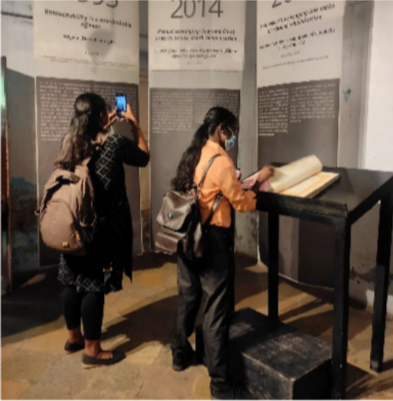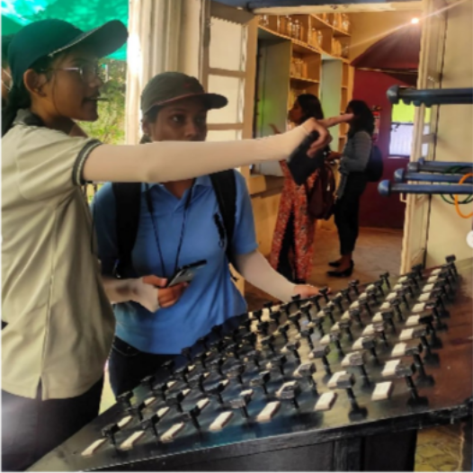
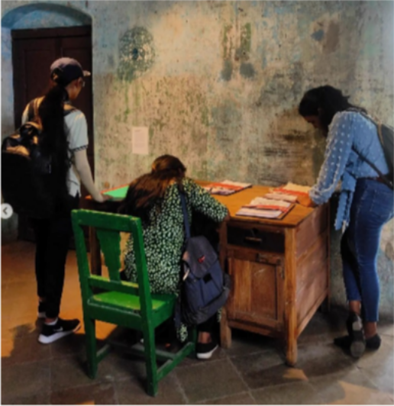
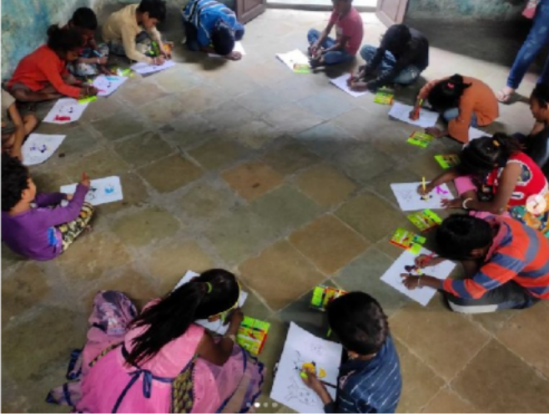

June
IDIA Scholars - increasing diversity by increasing access, visited us recently as part of their program with Center for Social Justice (@csj_india )
They have been in a workshop with CSJ for developing their critical legal skills like research writing, argument formation for moot court competitions, understanding action research and access to justice through fieldwork. The scholars are from different parts of India from esteemed universities like National Law Universities and other private law universities.
As Conflictorium, wherein we are continuously thinking through accessibility - of Museum as an institution and experience to varied social contexts and imaginations - this visit furthered our thought to the various methodologies and challenges of responding to people with disabilities, deepening our interest in making Museums more tactile and intimate.

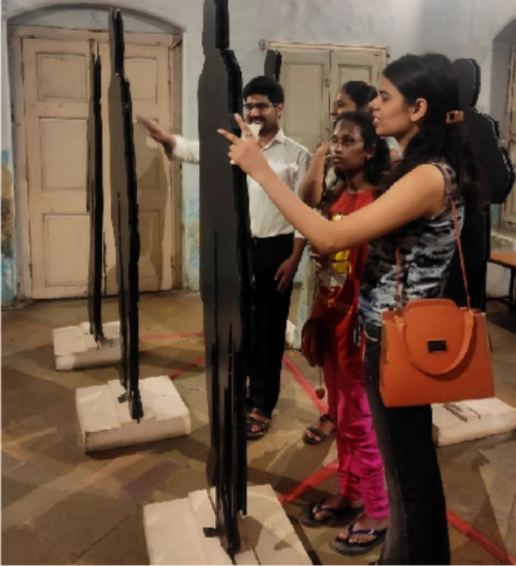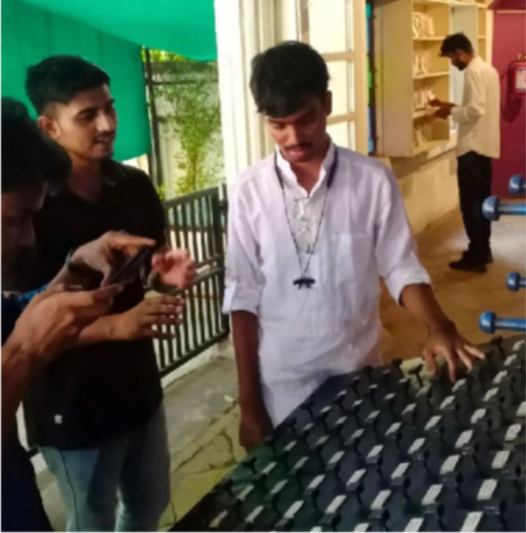

November
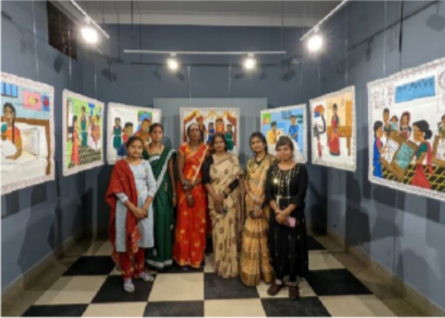
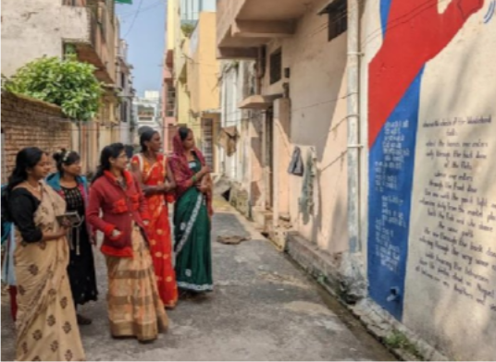
Art practitioners from @hastvem hastkari - who have contributed the hand painted fabric depicting the story of Godna art's changing medium from skin to clothes, visited us on Sunday. Yogeshwari Dewangan, Suruchi Dewangan, Khowa Devi, Dameshwari, Nisha Dewangan and Surbhi Gupta traveled around 150 km on their day off to experience their art on display and to share their thoughts on the exhibition. Their art work was part of the exhibition 'Markers and Morality' - based around rearticulating Article 25 of the Indian Constitution.

