ANNUAL REPORT 2022-

2023

Institute for Studies And Transformations (IST)

Ahmedabad

OBJECTIVE 1: TO GUIDE TRAIN, TEACH, SENSITIZE INDIVIDUALS AND COMMUNITIES TOWARDS THEIR SOCIO-ECONOMIC DEVELOPMENT
Introduction
A. IST secretariat support provided for CBOs and other partner organizations for youth development work
IST, through its role as a secretariat for various CBOs, collectives of youth, and other partner organizations, plays the role of capacity building for the various Youth facilitators involved in engaging with the youth across Gujarat geography on constitutional values, peace, and conflict transformation. The functions that IST plays include:

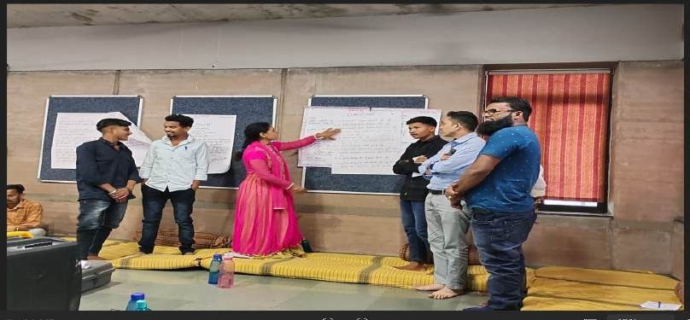

- Identification, capacity building, and handholding support for community leaders and facilitate them to setup and run community-based organizations.
- Identification and capacity building of community level para-legals.
- Capacitating and empowering young citizen leaders and providing hand holding support for their community-level initiatives.
A.
Identification and capacity building of Community Organizers and youth
Facilitators:
The IST Secretariat has supported the CBOs to train and develop youth facilitators and community mobilizers. Together, they have meticulously identified and compiled a list of 164 villages and urban localities across various districts and blocks where our intervention is active. This strategic effort aligns with our commitment to fostering positive change and community development within these specified regions.

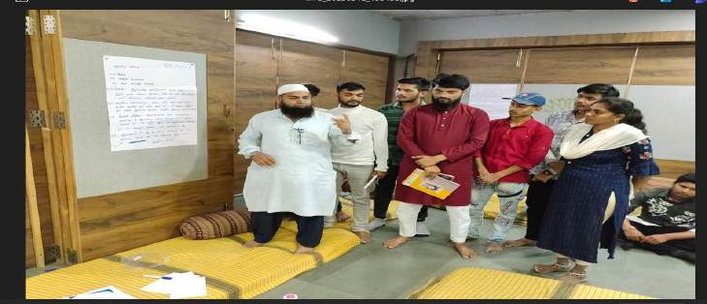

Sr. | Name of the  District | Blocks | Selected Villages  and urban localities
1. | Ahmedabad city | Gomtipur, Amraiwadi,  Behrampura Areas | 03
2. | Sabarkantha | Himmatnagar and Idar | 48
3. | Anand – Kheda | Umreth, &Thasra | 23
4. | Panchmahal | Gogambha, Jambugoda, Halol | 70
5. | Aravalli | Modasa | 20
Total |  |  | 164

M&E support for data management and assessment of indicators for growth of community leaders:
Monthly Review, Monitoring and Support Meetings: In this reporting period, we conducted eight monthly meetings, comprising three two days sessions, three meetings of three-day sessions, and two one-day session. These meetings focused on:
  - Concise reviews of accomplished work,
  - Strategic planning,
  - Execution strategies,
  - MIS structure establishment,
  - Individual learning,
  - Experience sharing,
  - And, providing inputs.

Through these interactions, team members glean insights from each other’s experiences and contribute valuable input to address raised issues or concerns. Additionally, we implemented fortnightly local meetings at the district level, fostering quick responses to emerging issues, experience sharing, and mutual support. Administrative matters such as monthly work reports, expense submissions, and MIS data were also addressed during these meetings.

B.
Support in Identification, Capacity building and handholding support to
community leaders & CBOs
In the last reporting period, our team identified and collaborated with 33 community-based leaders, assisting them in accessing rights and entitlements for marginalized communities. IST Secretariat continued its support for existing CBO leaders and their setups, providing strategic planning assistance aiding in the design of event and programs. The team facilitated initiatives addressing local community concerns.
IST Secretariat develops the resources and training modules for the CBOs to onboard for conducting various induction and orientation activities. Along with this the Secretariat also develops the specific thematic trainings by bringing in experts from that specific domain.

Sr. No | Name of the CBO’s | Issue /Theme of work | District / Area | No. of community  leaders leading the CBO
1 | Neev Charitable Trust | Community based Education Centre led by young DNT leader (denotified tribe) focusing on strengthening culture of education in his  community | Ahmedabad / Saraspur | 3
2 | MAA education and charitable and welfare Trust | Community based Centre facilitating civic entitlements and rights to the needy poor (Primarily focusing on Muslim & DNT  communities) | Sabarkantha / Himmatnagar | 3
3 | Sarvodaya charitable Trust | Promoting Health and Education in Muslim community especially girl child education and  women’s health | Panchamahal / Halol | 11
4 | Nisulk Seva Margdarshan Kendra | Community based centre for civic entitlements and rights  for the needy poor | Modasa | 5
5 | Ekta charitable Trust | Relief and access to entitlements work to the  differently abled people | Mahisagar / Balasinore | 3
6 | Manav Sewa | Education Work | Gandhinagar /  Dehgam | 3

7 | Savitri Bai Fule and  Fatima Shaikh Learning Centre | Education Centre for Muslim Girls | Ahmedabad / Juhapura | 5
8 | Swanirbhar Charitable Trust | Working for providing entitlements and documents for NT-DNT community | Himmatnagar / Sabarkantha | 11
9 | Ekta Charitable Trust | Relief work | Savgadh / Sabarkantha | 13
10 | Power of Unity | Relief and entitlements work | Umreth | 12
TOTAL |  |  |  | 69

A three-day residential training was conducted for community leaders hailing from Aravalli, Sabarkantha, Panchmahal, Anand and Ahmedabad district. The program, held at Neembadi, Sanand, included participants from Muslim, Dalits, Adivasi and OBC communities. The objective of the training was to enhance their leadership skills, fostering collaboration on common issues across diverse communities. Most leaders represented small community-based organizations, and the training also aimed at fortifying these CBOs. Discussions during the training resulted in the identification of local issues and the development of corresponding plans, with education, livelihood, and health emerging as predominant concerns. The training also introduced the concept of “Manch” to strengthen its presence across different districts.
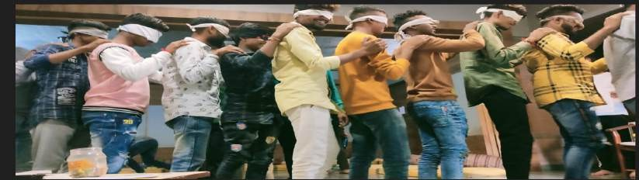
C.
Support and hand-holding for the CBOs and partner organizations for
identification and capacity building of community level para-legals:

IST Secretariat sought facilitation support from the Centre for Social Justice (CSJ) to conduct capacity-building training for para-legals. The training covered various aspects of law including,
- Fundamental rights and Duties
- Right to information Act (RTI)
- Domestic Violence Act
- POCSO Act
- Right to Education Act (RTE)
- FIR filing procedure and understanding on Chargesheet
- Application filing in State Human Rights commission and National Human Rights Commission
- Fake news check and social media related offences

- Theories of Punishments and concept of Justice
- Rights of the accused
- Structure of criminal courts
- Hirearchy and structure of Police functioning
- Role of Legislative Assembly

After the second training, para-legals leaders initiated planning to implement their new found knowledge. Active para-legals launched the intermodular initiative,
  - Filed 17 RTIs on issues related to Waqf concers,
  - Land records information in land issues,
  - Scholarship issues,
  - Panchayat grant allocation, and
  - Compensation demands from CM fund.

  - Application to appoint the committee members as per the Waqf Act in Haj Committee.
  - Application to CM for demanding compensation for the person died in Tiranga Campaign of Govt. due to electric current on high tension wire.

  - Additionally, application was submitted for:
    - Legal action in a cheque bounce fraud case,
    - Provision of dustbin at Malivada,
    - Removal of illegal authority from the panchaya,
    - Addressing water logging at Zahirabad Panchyat
  - Notice was issued against illegal possession of waqf land through district collector.
D.
Creating frameworks for capacitating young citizen leaders and hand-holding
support to them in taking up community level initiatives:
The IST Secretariat persist in our commitment to engage and provide support to the young citizen leaders who have been affiliated with us for past several years. These emerging leaders are now independently spearheading community-based initiatives, actively participating in districts and state-level endeavours led by various movements and organizations. They advocate for marginalized communities' rights, entitlements, and justice, with some establishing organized groups, running centers, and conducting community-level activities.
The Secretariat facilitated and organized various programs and events that involved these dynamic young citizen leaders. The IST Secretariat provided policy research, organizing strategy-oriented support to the various teams of youth facilitators.
IST Secretariat has successfully conducted two more capacity-building programs to enhance leadership skills and foster the sharing of insights gained from their respective initiatives. Our focus extended to fortifying participants’ social perspectives on issues such as caste, gender, and communalism and engaging in discussions on pertinent current affairs in the state and the country. These discussions encompassed their understanding of communal violence, caste issues, human rights, the increasing threat to the constitution, election processes, and their impacts on the lives of marginalized communities.

Notably, the Secretariat initiated a dedicated workshop for young girls, a strategic move to bolster female participation in our various initiatives where we identified a gap. A total of 60 young girls actively participated in this workshop. The overarching objective was to ensure inclusivity and increased representation of girls and women in our programs.
Furthermore, teams were facilitated and nudged for the development of a plan and concrete actions by youth to strengthen a culture of diversity. This involved promoting diverse practices in the everyday lives of youth within the communities they engage with. Each person was facilitated to design and develop their individual youth action plan. Additionally, collective block-level activity plans were formulated to engage numerous youth in various conflict transformation events and processes.

Sr.  No. | Programme Details | Place | No. of YCL  participants
1 | Leadership building & designing individual  youth actions | Neembaadi, Sanand | 48
2 | Leadership building & designing individual youth actions with  young girls | Neembaadi, Sanand | 60

Youth Empowerment: A transformative three-day camp in Udaipur- Advisory by the Secretariat for the program design

Additionally, a three –day Youth Camp was organize from September 7th to 10th, 2023, in Udaipur. A total of 78 participants from Ahmedabad, Panchmahal, Anand, Kheda, Modasa, Himmatnagar, Idar and Prating actively participated in the camp. The primary objective of the camp was to enhance youth activities, strategize the creation of new youth spaces, provide insights into the current social scenario, and encourage creative planning for engaging more youths to develop their leadership skills.

Throughout the camp, participants understood how their needs and human rights are interconnected. They explore the correlation between fundamental rights and duties, delved into existing youth spaces where significant interaction and learning occur, and engaged in various games to comprehend the role of collective leadership.

Discussion during the camp included an examination of youth policies and the identified needs of the youth. The culmination of the camp involved taluka-wise and individual planning of activities, as well as the development of different youth spaces. Creative ideas emerged including:

- The proposal to create a youth-run YouTube channel dedicated to promoting peace and harmony.
- Youth-led spaces for various activities.
- Setting up libraries in different locations.
- Mobilizing funds through community piggy banks to support different activities.
- Initiating different sports activities.

- Film screening on different subjects.
- Learning of different languages.
- Meeting once in three month.

The camp facilitated the generation of innovative strategies and plans to empower and mobilize the youth for positive social impact.
Conclusion:
The IST Secretariat has helped operationalize and support CBOs to work with the most marginalized communities in Gujarat. The teams brought in by various CBOs have seamlessly integrated into the system, effectively facilitating various processes. The program’s objectives have been pursued diligently, with significant interventions made by youth, para-legals, community leaders, and the members of the Manch.
Several capacity-building programs, camps, and an annual conclave for YCL have been conducted, resulting in the formulation of individual change and plans that have, in turn, led to various community-level activities and initiatives. The various conflict transformation process led by the youth resulted in bridging the gap between the different communities. Implementing MIS systems and formats has been developed to strengthen individual and collective growth journeys. The Manch initiatives such as fact-finding reports, legal interventions, and community engagement, the organization have worked towards safeguarding cultural heritage, preventing communal violence, ensuring legal compliance, and fostering communal harmony.
Furthermore, the emphasis on community-based organizations, para-legal training, and continuous capacity-building efforts underscores the commitment to sustainable development and empowerment at the grassroots level. However, we are addressing the challenge of increasing the participation of young girls and to mitigate the ongoing fluctuation of team members within various partner organizations engaged in the Youth work.

OBJECTIVE 2: TO SUPPORT THE DEVELOPMENT OF THE NEEDY, DEPRIVED AND DISADVANTAGED THEROUGH VARIOUS DEVELOPMENT INIRTIATIVES

A. Revitalizing Rainfed Agriculture (RRA) Network Hub
The emphasis of RRA Network's work in 2021-2022 has been networking and policy deliberation. Looking back on the road traversed in the past three years, other achievements of the network have been establishing state networks in Maharashtra, Himachal Pradesh, and Karnataka and creating, as verticals, thematic working groups. The working groups on soil, seed, water, millets, agroecology (previously System of Rice Intensification—SRI), and markets are well established, while those of livestock and forest rights are still in a formative stage. Taken together, these working groups represent an integrated approach that would allow for a knowledge-centric revitalization of the diverse agroecosystems of rainfed areas. Also worthy of mention are the national and international collaboratives at the RRA Network, which joined in 2020. It played a formative role in shaping the National Coalition of Natural Farming and is a member organization of the International Food and Land Coalition (India). The Network's knowledge and experience on rainfed agriculture is thus shared now across broader forums. RRA Network Hub now actively engages in international dialogues around agroecology, nutrition, human resources in agriculture, climate resilience, and land degradation and presents at or participates in national events around these themes. Mention must be made of the Network's response to the distress of stranded migrant workers across the country due to the COVID-19 lockdown: the Network's spread over 11 states allowed it to immediately help those in need with food, shelter, and transport. Later, for greater resilience and lasting impact regarding nutritional security with homestead production, we started a Kharif campaign, encouraging farmers in 6 states to grow food crops in a quarter- acre plot of their land.

NETWORKING

- Network Communication
The RRA Network facilitated discussions within partners to take up policy-related initiatives on the following 5 thematic tracks:

Millets | Markets and Institutions | Indigenous Multi-croppingSystems (IMCS)
Seeds | Livestock | Indigenous Multi-croppingSystems (IMCS)

  - RRA Network Daily News compilation: The RRA Network daily digest was duly compiled on a daily basis within this period and sent to all our subscribers.
  - Documentation of Best Practices: Numerous short blogs, 3 photo stories on rainfed agriculture, the need for critical irrigation and seed systems in rainfed areas and 3 videos (each approx. 3 minutes) on the same themes capturing best

practices on different aspects of rainfed agriculture were published in this period.
  - Annual Network Meeting: A two-day national consultation on Moving Forward: Making Rainfed Agriculture Resilient and Remunerative was organised by Revitalising Rainfed Agriculture (RRA) Network on 4-5 November, 2022 at Hyderabad. Over 120 participants attended this consultation to deliberate upon and finalise the agenda of the Network for the next 5 years. The event saw representation from the following categories of institutions:

40  Civil Society Organizations | 4  Research Institutions | 4  International Institutions | 3  Donors

  - People’s Convention on Millets for Millions: A two-day nation convention on Millets for Millions was organized by RevitalisingRainfed Agriculture (RRA) Network in collaboration with NRAA and network partners on 24-25 November, 2023 at New Delhi. Over 1000 participants across 18 states attended this people’s convention to deliberate upon and finalizing strategy for mainstreaming millets. The stakeholders involved in the discussion were govt. depts, CSR/ foundations, NABARD, civil societies, universities & research organization, community organization and farmers.

- Working Group and State Network Facilitation: Facilitating the work of 3 state network and 5-6 thematic working groups is the core work of the Network. The RRA Network plays a crucial role in helping these groups to develop their 5-year agenda and also short-term proposals for submission to the Advisory Committee of RRA Network. It gives inputs on the objectives being pursued by these groups and monitors their progress. Towards these objectives, the RRA Network hosts a weekly online meeting which is attended by the anchors, coordinators, and representatives of these groups. Following are the achievements under this objective:

STATE NETWORKS
  - MahaRRAN (Network in Maharashtra): The RRA Network gave significant inputs and participated in the MahaRRAN strategy planning meeting in May, 2022 as well as helping them to raise funds for developing a State Rainfed Agriculture Perspective. It also gave inputs and participated in district-level meetings for the development of a District Rainfed Agriculture Plan in Osmanabad, Amravati, and Nagpur Division (6 districts).
  - KarRRAN (Network in Karnataka): The RRA Network provided inputs and participated in a conference held in Karnataka in May 2022 by KarRRAN on bettering public partnership for sustainable agriculture & livelihood in rainfed areas.
RRA Network was instrumental in facilitating a partnership between GIZ and KarRRAN partners to launch the India Biochar and Bioresource Network

(IBBN) to disseminate information about the properties and use of biochar. RRA Network also facilitated collaboration between the Seeds Working Group and KarRRAN to build capacities of farmers & CSOs on seed landraces in Karnataka. Similarly, it facilitated collaboration between the IMCS thematic group and KarRRAN to research, analyze and document “Akkadi Sallu” (an indigenous cropping system) techniques.
  - HimRRA (Network in Himachal Pradesh): RRA Network facilitated collaboration between the Seeds Working Group and HimRRA to conduct a 3- day residential training program on Indigenous Seeds & Seed Systems in April 2022 at Palampur, Himachal Pradesh to build capacities of the participants on this theme. RRA Network also helped to build the capacities of the members of HimRRA by organising a 4-day online training on “Natural Farming: Principles & Practices” along with National Institute for Agricultural Extension Management (MANAGE), Hyderabad & State Agricultural Management & Extension Training Institute (SAMETI), Shimla. RRA Network supported HimRRA in preparation of a proposal and action plan on Natural Farming in Gram Panchayats and the action plan focusses on promotion of indigenous seeds and cultivation of millets. RRA Network helped HimRRA to report on the Millet Awareness event in November 2022 that was held for government officers in Chamba, an “aspirational” district.At the event, children and other participants got to try out new millet dishes that can be included in the government’s ICDS nutrition scheme for the district.

THEMATIC WORKING GROUPS
  - Seeds: The RRA Network supports the Seeds Working Group, as and when needed, to facilitate conversations with government agencies across the State & National level to facilitate needed policy shifts in promoting viable seed systems for rainfed areas. It also facilitates the work of the group in different states especially where RRA Network has a presence such as Himachal Pradesh and Karnataka. The RRA Network played an important role in facilitating the Seeds Working Group work in promoting Neglected and Underutilized Species (NUS) in 3 states of India. It helped develop Standard Operating Procedures (SOPs) and policy processes for NUS.
The RRA Network on a need basis, have given inputs to the work of the Seeds Group which includes setting up community-managed seed systems, mapping of landraces or indigenous varieties, diversification of field crops, establishment of PDB (Paddy Biodiversity block) for multiplication and preservation of seeds of traditional varieties and promoting kitchen gardens for home nutrition, where 14 types ofindigenous vegetable crops can be grown, and setting up a seed exchange portal for farmers for indigenous landraces.
- Millets: The Millets Working Group supported by the RRA Network have had preliminary discussions with autonomous government agencies in Jharkhand and CSOs in Rajasthan to promote millet cultivation and consumption at scale in selected districts. A training programme for trainers to promote millet cultivation has also been planned. The RRA Network participates in a

programme, funded by Rainmatter Foundation, to develop an “ecosystem of support services” for nurturing millet cultivation and consumption locally. To that end, RRA Network has taken up 3 pilot sites in the states of Maharashtra, Himachal and Jharkhand.

- Partnership building with Central/ State/ District mainstream programmes (Design to Delivery): Partnership building was actively pursued with District Collectors and Divisional Commissioners in the states of Himachal Pradesh and Maharashtra, as detailed above, to institute appropriate policies for rainfed agriculture. These meetings will lay the groundwork for mainstreaming government programmes (from design to delivery) for resilient rainfed agriculture as envisaged in the proposal.

- Innovative Support Services for Practice to Policy Pathway initiatives: In this period, RRA Network Hub has initiated the process of reviving or venturing into 3 new thematic areas, namely that of IMCS, Livestock, Markets and Institutions. This was done by identifying people and organisations with experience in these themes, building relationships and hosting discussions. The agenda for each of these 3 thematic groups was deliberated upon at the national consultation event in November and strategies to take up the same were formulated. The RRA Network Advisory Board recommended that these 3 new thematic groups be supported to further develop their ideas in an incubation period for a few months.
- Engagement with other networks and institutions: To pursue the rainfed agriculture agenda in the Bundelkhand region (a development shadow area), RRA Network brought together CSOs working in the environmental and developmental sector to take up the rainfed agriculture agenda in that region. A strategic plan based on a scoping study to make rainfed agriculture resilient will be the first outcome of these discussions. RRA Network deepened its collaborations with other national networks that work with farmers such as Rapid Community Response to Covid (RCRC) Network, National Coalition of Natural Farming (NCNF), ASHA Kisan Swaraj, Food and Land Use Coalition (FOLU), India and WGWLO. In terms of supporting each other’s work with agrarian communities or extending the geographical coverage of work.
- It also actively took collaborated with National Rainfed Area Authority (NRAA), Deutsche Gesellschaft für Internationale Zusammenarbeit (GIZ), Welthungerhilfe (WHH), Maharashtra Knowledge Corporation Limited (MKCL), World Food Programme (WFP), Central Research Institute of Dryland Agriculture (CRIDA), National Institute of Agriculture Extension Management (MANAGE) by helping them in programmes and projects of mutual interest.
- The RRA Network also participated in the Food Systems Dialogue (FSD) India, held in November 2022, by Bharat Krishak Samaj and others. It also participated in the EAT-LANCET India consultation that was convened right after the FDS. At both these international events, RRA Network engaged with several organisations and pointed out the need for resilient food systems in the rainfed areas of India that promoted social Equity, regenerative Ecology, and a remunerative economy.

SUPPORTING RESEARCH AND DOCUMENTATION

Promoting Research Collaboration with key institutions:
- As the knowledge partner of MANAGE, the national farmer training institute, RRA Network helped in a massive pan-India capacity building programme to Gram Pradhans on Natural Farming. Till date a series of more than 1000 online awareness programs has been conducted which could reach out to more than 56000 Gram Pradhans & nearly 5-6 training sessions are conducted for master’s trainers across the country for wider dissemination of the idea of Natural Farming. In addition, a series of resource materials on thematic areas & success stories of champion farmers practicing NF has been documented & published in MANAGE website.
- The Network and HimRRAN supported the “Impact Evaluation of the Prakritik Kheti Khushhal Kisan Yojana (PK3Y) on Fertilizer and Pesticide use in Himachal Pradesh” conducted by MANAGE, on request of the Department of Agriculture, Government of Himachal Pradesh, to understand the impact of the aforementioned scheme on chemicalfertilizer and pesticide use.

- In addition to the collaborating with key institutions, at the request of a core advisor of RRA Network, the research team undertook a theoretical research study of the nationally influential Andhra Pradesh Community-managed Natural Farming (APCNF) programme implemented by Rythu Sadhikara Samstha (RySS) under the aegis of Department of Agriculture, Government of Andhra Pradesh. This study was a literature review of 24 studies to apprise strengths and challenges of the APCNF programme and identify gaps and research needs.

- The RRA Network Hub as part of the Food and Land Use Coalition (FOLU), India, contributed to a forthcoming research publication of FOLU, India called Action Agenda. The Network contributed to sections on resilient rainfed agriculture, localised supplychains, and agrobiodiversity.

Challenges and concerns
In today's urbanized and globalized world, there is little space for us in civil society to raise our concerns about deteriorating soil health, water resources, biodiversity, and rural incomes, particularly in rainfed areas. Agriculture and the investments it requires are simply not a matter of everyday concern for many Indians. Even the farmers' immediate needs and short-term aspirations are not always in sync with the integrated ecological approach we promote. Apart from initiatives, such as strengthening backyard poultry, which results in an immediate increase in income, our recommendations to conserve water or build soil health do not result in immediate benefits for the farmers. Hence, for us, public investments are key to reviving India's dying lands and increasing productivity in rainfed agricultural systems.

However, the changes we want to bring about are not always aligned with the political climate and the government's will. India lags behind the West, especially the European Union, where concern for the environment and safe food have become citizens' demands. We find that our vision of increasing rural incomes through the regeneration of sustainable, diversified, rainfed productive systems is very much in keeping with the growing international discourse on agroecology. We thus look forward to the opportunity to contribute our expertise on India's rainfed agriculture to this international discourse. In the meantime, in India, we continue to seize whatever opportunities present to take up the rainfed agenda in various states. We also engage in movements that are in synergy with ours, such as Natural Farming.

OBJECTIVE 3: TO WORK TOWARDS THE CREATION OF A HUMAN ORDER IN SOCIETY FOUNDED ON UNIVERSAL LOVE FOR ALL CREATURE
A. Conflictorium – A participatory museum promoting peace and fraternity

NEW MUSEUM OPENING

Conflictorium opened in Raipur, Chhattisgarh | April 2022 Conflictorium, Raipur is a multidisciplinary interactive museum that explores the socio-economic and environmental plurality of Chhattisgarh. Its primary aim is to establish a strong presence in Raipur through exhibitions and events focused on citizenship, faith, and culture-making across indigenous and urban contexts. Over the past two years, the museum has engaged more than 1,000 visitors. It has collaborated with over 30 artists across 5 exhibitions and 20 events. These programs include open mics, screenings, performances, workshops, and residencies. The museum prioritizes local artistic practices and meaningful engagement with diverse audiences, especially you
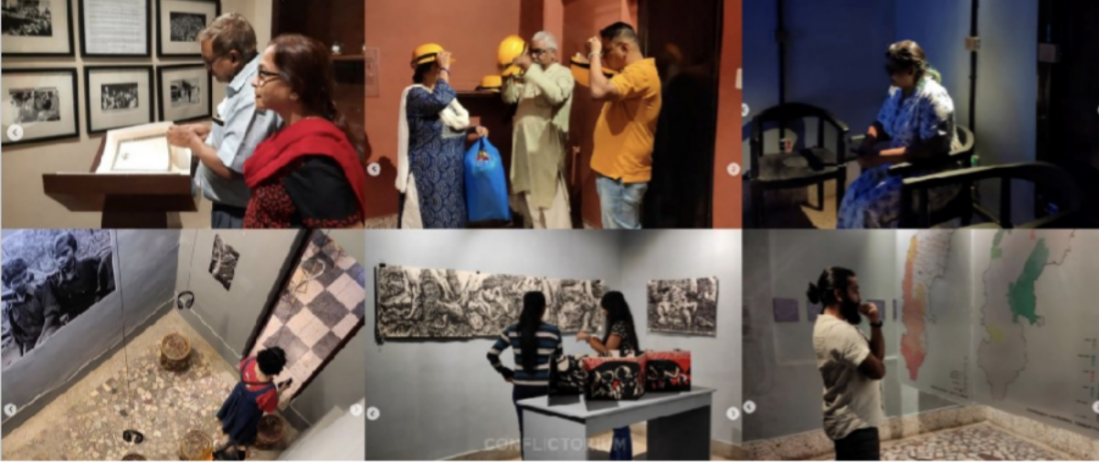

EXHIBITIONS

April 2022 Imagining a Forest
Conflictorium’s Imagining a Forest examined questions of ownership, access, and how forests are imagined, challenging the idea that plantations can replace living ecosystems or their people. It questioned whether urban existence remains caught between guilt and awareness, or moves beyond exhibitionary reflection. The work located this tension beyond binaries, at the point where human imagination begins to fail.

June 2022
Still, We Can’t Step in the Same River Twice

The exhibition views India’s current socio-cultural-economic crisis as a recurring historical condition rather than a recent development. Still, we cannot step in the same river twice, under the theme Again and Again and Again, explored how repetitive everyday practices can be reimagined—shifting from waiting for a savior to asserting our rights.
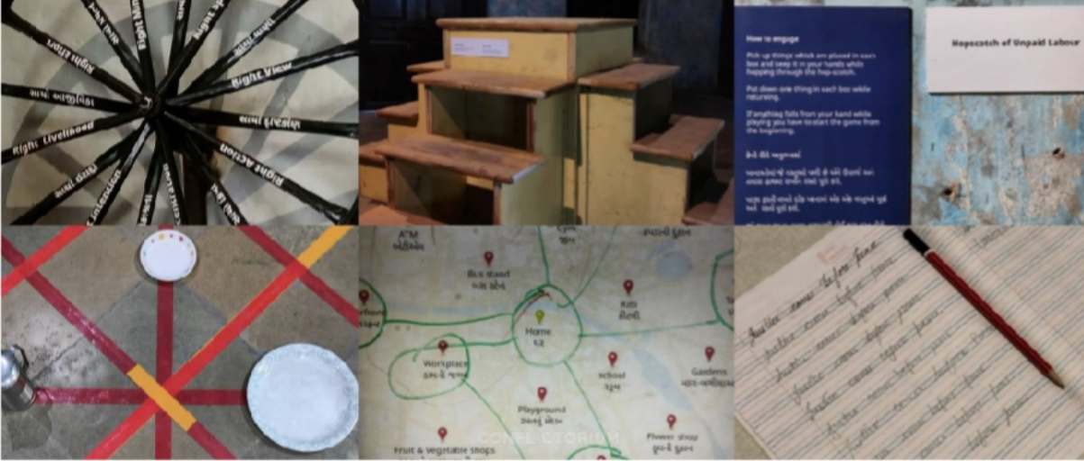

September 2022
What Was To Pass, Remained
Conflictorium in collaboration with Budhan Theater (@budhantheatre) and Bhasha Research Center, supported by the University of Leicester, for an exhibition articulating a brief history of denotified and aadivasi tribes through the covid pandemic. The exhibition was the outcome of an ambitious community-led project by Budhan and Bhasha that, since the beginning of the pandemic, documented the lockdown and post-lockdown experiences of DNT and Adivasi communities through the arts.

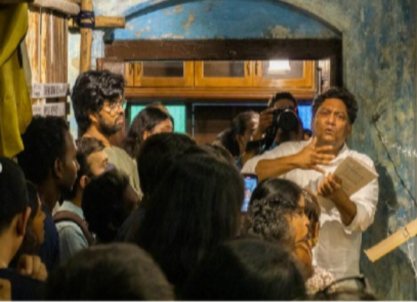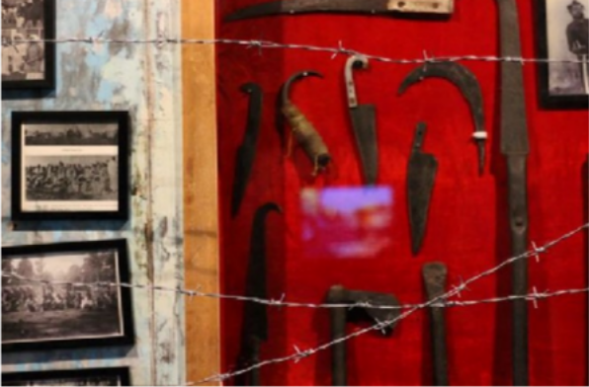

October 2022
Ambedkar as Feeling, Emotion and Instinct
“For me, Ambedkar is a poet of missing people, erased words, forgotten languages and cruel histories. I feel rage and nothing else when I read him. He tells me that without justice, no beauty in the world can be enough for humankind. My poems are bitter like Neem. Probably that is why you mistook my anger for lovelessness..." A collaborative work - exploring and expressing B. R.

Ambedakar's principles beyond the discourse of Law and Judiciary - by Yogesh Maitreya (@yogeshmaitreya) and Shiva Nallaperumal (@shiva_n_); an exhibition exploring and expressing B.R.Ambedkar as a figure of Love, Faith, Anger, Poetry amongst all the other roles and spaces he has made possible in the discourse of Freedom.

November 2022 Markers and Morality
Religion, throughout its frenzied history, has occupied a pedestal, one that makes reflection on it difficult. Despite legal recourse that decry freedom, how free are we around religion and it’s external and internal manifestation? Using discomfort as a stimulus, this exhibition - 'Markers and Morality' is an inquiry into the freedom around religion and the social and personal context, especially around those that don’t have a scripture or even a universal language.

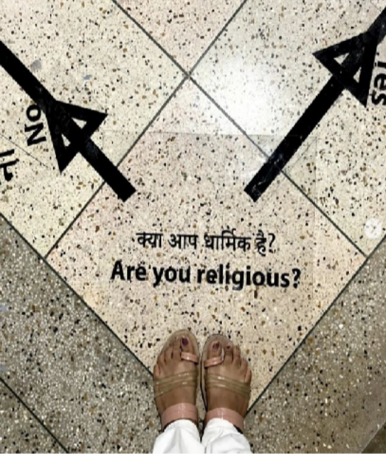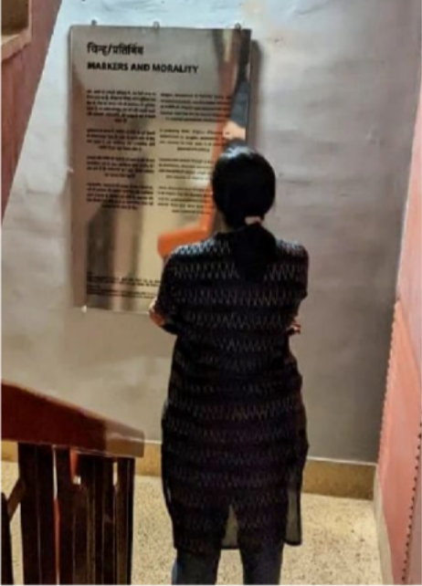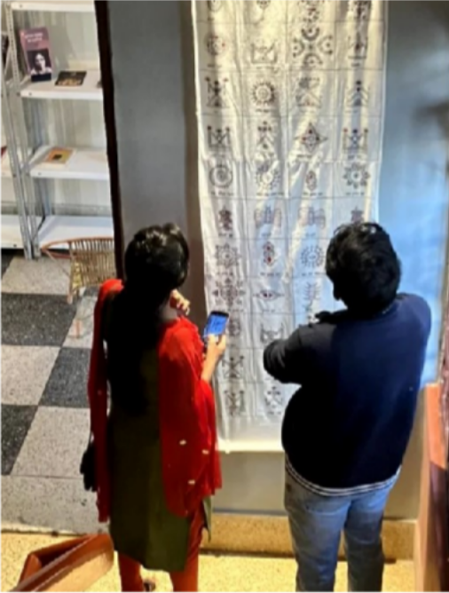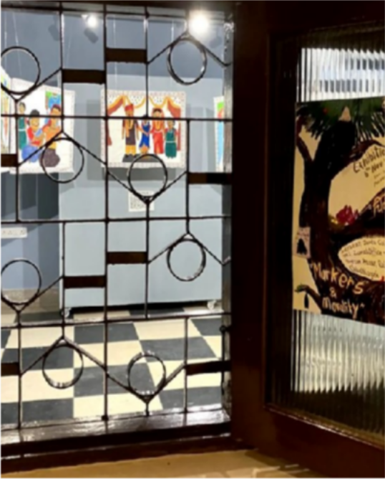

ARTIST RESIDENCY

Uche James Iroha, from Nigeria | July 2022
We hosted Uche James Iroha - lens-based artist and critical culture thinker - at our Artist Residency this July. As part of the larger framework of South-South solidarities, we explored both the homogenous and the heterogeneous experiences of Culture between India and Nigeria - from trade to weddings to cinema! Uche also engaged with academic institutions, the ravivari market, siddi community, and met with our other dear friends: some artists, some thinkers, and some chai enthusiasts.

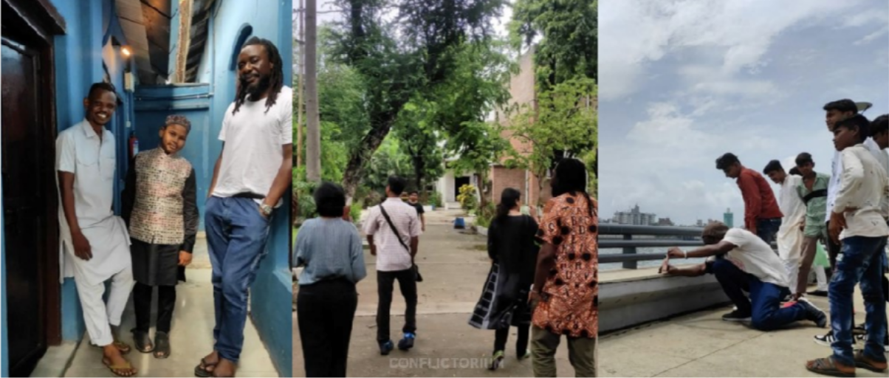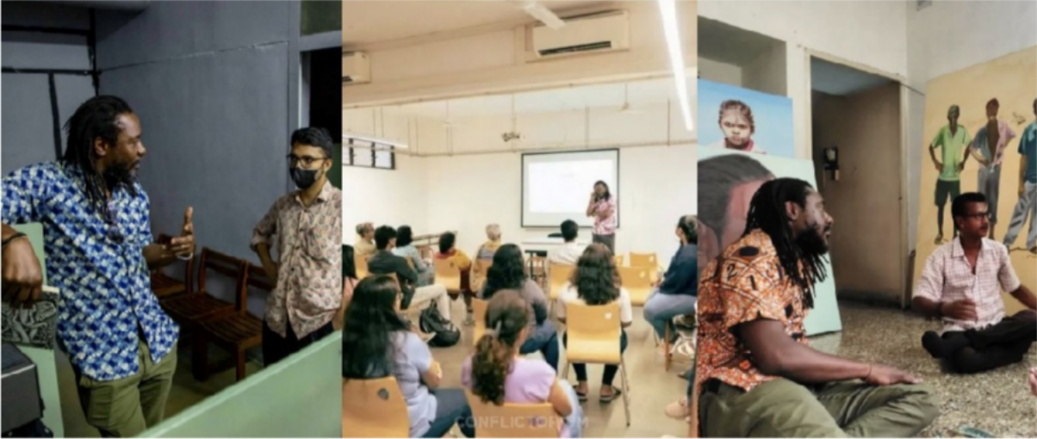

EVENTS (performances, workshops, poetry, reading groups, talks, etc)

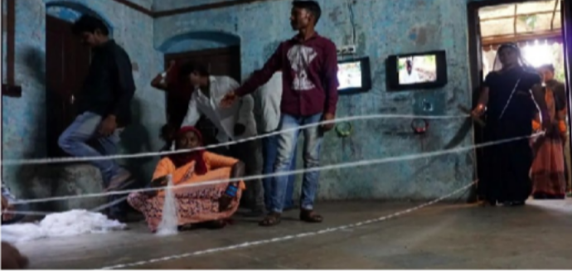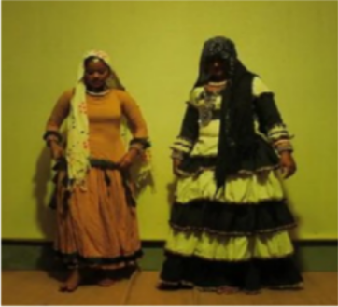
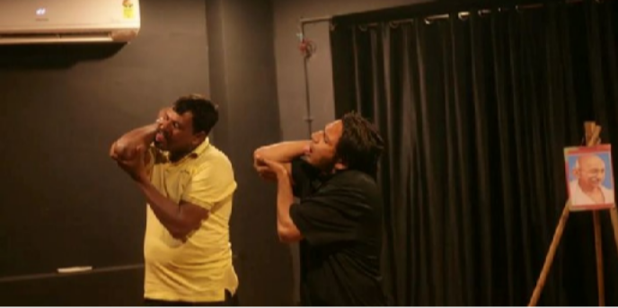
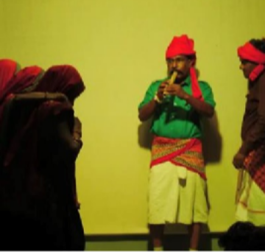

Aesthetics of Bodily Representation - a talk by Prof Y S Alone | November
Professor Y. S. Alone is presently working at the School of Arts and Aesthetics at JNU, and has published several journal papers on Ancient India Art, Ajanta and Buddhist Caves in western India , critics of Modern Indian Art, popular neo-buddhist visual culture, and interpretative framework of Dr Ambedkar and social sciences. He has also evolved the well known conceptual formulation 'protected ignorance'. His talk, under प चीस क पहचान | (re)art25 - a Conflictorium programme responding to the diatypes of Freedom of Religion and Belief in India , illustrated the evolving pictorial signification process in contemporary visual practices - building a discourse between freedom of religion and freedom of expression in Modern India.

Love, Faith and Freedom | December
Collectively sharing and examining our various experiences of transcendence and transgression - of faith, love, violence, conflict, freedoms.

Guessing the Great God | April
A workshop examining divinity as a site of both emancipation and control, questioning fear, faith, ritual, creativity, and differing ideas of God across mysticism, orthodoxy, politics, and everyday life.

Experiments of a Spect-Actor | April
An interactive session exploring how everyday life involves constant performance shaped by situations and social roles.

Desire Vs Guilt | April
A four-day workshop on the conflict between human desire and moral, social, and cultural restrictions.

State, Surveillance, Citizens | May
A session analysing citizenship and state power through visibility, control, and fear of being watched.

Pleasure-o-Pain | May
A discussion on how pleasure transforms into burden, pain, or even desire, questioning the nature of pleasure itself.

JOJO Editions at Conflictorium Raipur | June
A curated display of photobooks exploring personal and collective memory.

Once Upon a Village Film Screening | June
A screening of Ek Tha Gaon, exploring migration, abandonment, and emotional ties to a dying village.

The New in Repetition | June
A workshop inspired by Deleuze, examining repetition as a site of creativity.

In and Out of Meaning | June
A four-day workshop on the tension between meaning-making and meaninglessness in life and culture.

Instagram Takeover by Pranav Kuttaiah | June
An online exploration of urban power, subjecthood, and storytelling in India.

Narrative Analysis of the Film Cinema Bandi | July
A discussion on collective creativity and aspiration through a village-made film.

All Over Again | July
A four-day workshop exploring why oppression, power, and hope repeatedly return.

SwaVidhan by Kavish Seth | July
An evening of music, poetry, and participatory activities reflecting personal and political realities.

KalaKarigari | October & November
A weekend series highlighting the artistic labor and performances of denotified and nomadic tribes of Gujarat.

